A GUIDE TO COMPLETING THE ESA 50
The ESA50 form is part of the Work Capability Assessment, to decide whether capacity for work is limited enough to qualify for Employment and Support Allowance (ESA). It does not include everything used to score points on the test. This guide aims to assist you by including the whole test alongside the form’s questions. The questions all bear some resemblance to the descriptors but don’t reflect them exactly. You need, then, to consider what the test REALLY is for each section and to try to frame your answers to address that as well as the simplified and misleading versions on the forms. This is especially important as wrong decisions on whether people have limited capability for work and entitlement to ESA are regularly made and if the form shows how you meet the test this may assist you should you need to appeal. In this guide we refer to HCP (healthcare professional) guidance, which is guidance produced by the DWP for the healthcare professionals who carry out the assessment ’medicals’. If you have a support worker/social worker/nurse etc, see if they will help you with the form.
The Work Capability Assessment is also used to decide whether a Universal Credit (UC) claimant has limited capability for work and limited capability for work related activity, and what work related requirements you will be asked to do. The form for this is called the UC50 and although the layout may be different it asks essentially the same questions, so please also use this guide to help.
Please note that for new ESA claims from 03/04/17 no Work Related Activity Component is paid and for new referrals for the WCA in UC from 03/04/17 no Limited Capability for Work element is paid. (There are some exceptions for linked claims - please seek advice). This means that unless you qualify for the Support Group in ESA or the Limited Capability for Work Related Activity element in UC, you will not receive extra payments for being too sick to work and will be paid at the same rate as a jobseeker.
You will be sent the form to complete, alternatively you can complete the PDF form available on https://www.gov.uk/government/publications/capability-for-work-questionnaire. Print out a copy and return it in the envelope enclosed with the copy of the form you have been sent by the date given in the accompanying letter.

Published by the Welfare Rights Team, Tackling Poverty Unit, City & County of Swansea May 2017

NB: This publication was correct at the time of printing, but benefits law frequently changes so this guide should be used in conjunction with independent benefits advice.
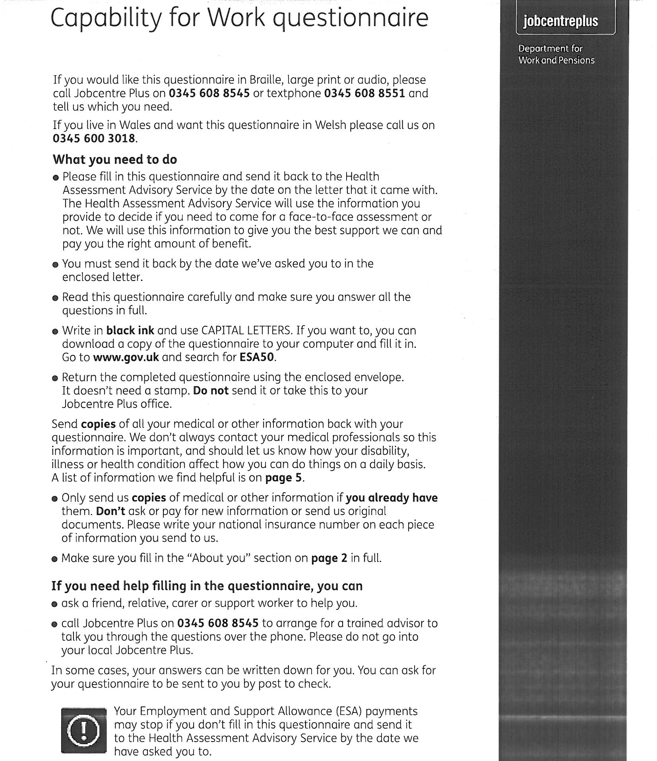

This form is your signed statement of how your health affects you and the activities you have problems with, it is important as you are completing this form because you do not currently feel well enough to either return to work or look for work. Get help if you find the questions confusing or don’t understand something on the form.
The Work Capability Assessment (WCA) is divided into two parts, the first part determines whether you have limited capability for work or can be treated as having limited capability for work and therefore entitled to ESA. The second part determines whether you also have or can be treated as having limited capability for work related activity and should be placed in the support group of ESA. This is important if your health means that you are currently not capable of preparing for work or attending the work related activity the DWP has available in your area. This has now become even more important, especially if ESA is your only source of income and your new unlinked claim was made after 02/04/17 as if you are assessed as only having limited capability for work your ESA will be £73.10pw but if you are also assessed as having limited capability for work related activity this increases to at least £109.65pw (with an extra premium added if you are receiving income-related ESA - always check with an advice agency if you are receiving all the income-related top ups you are entitled to as mistakes are frequently made).
The first part of the WCA is divided into physical descriptors—you cannot manage the activities due to a ’specific bodily disease or disablement’ and mental, cognitive and intellectual function descriptors– you cannot manage the activities due to a ‘specific mental illness or disablement’. To ensure you are assessed fairly, if your mental health has caused physical symptoms, e.g. irritable bowel syndrome or your physical health affected your mental health causing stress or depression—explain this on the form and make sure your GP is aware and this is explained at any face-to-face assessment.
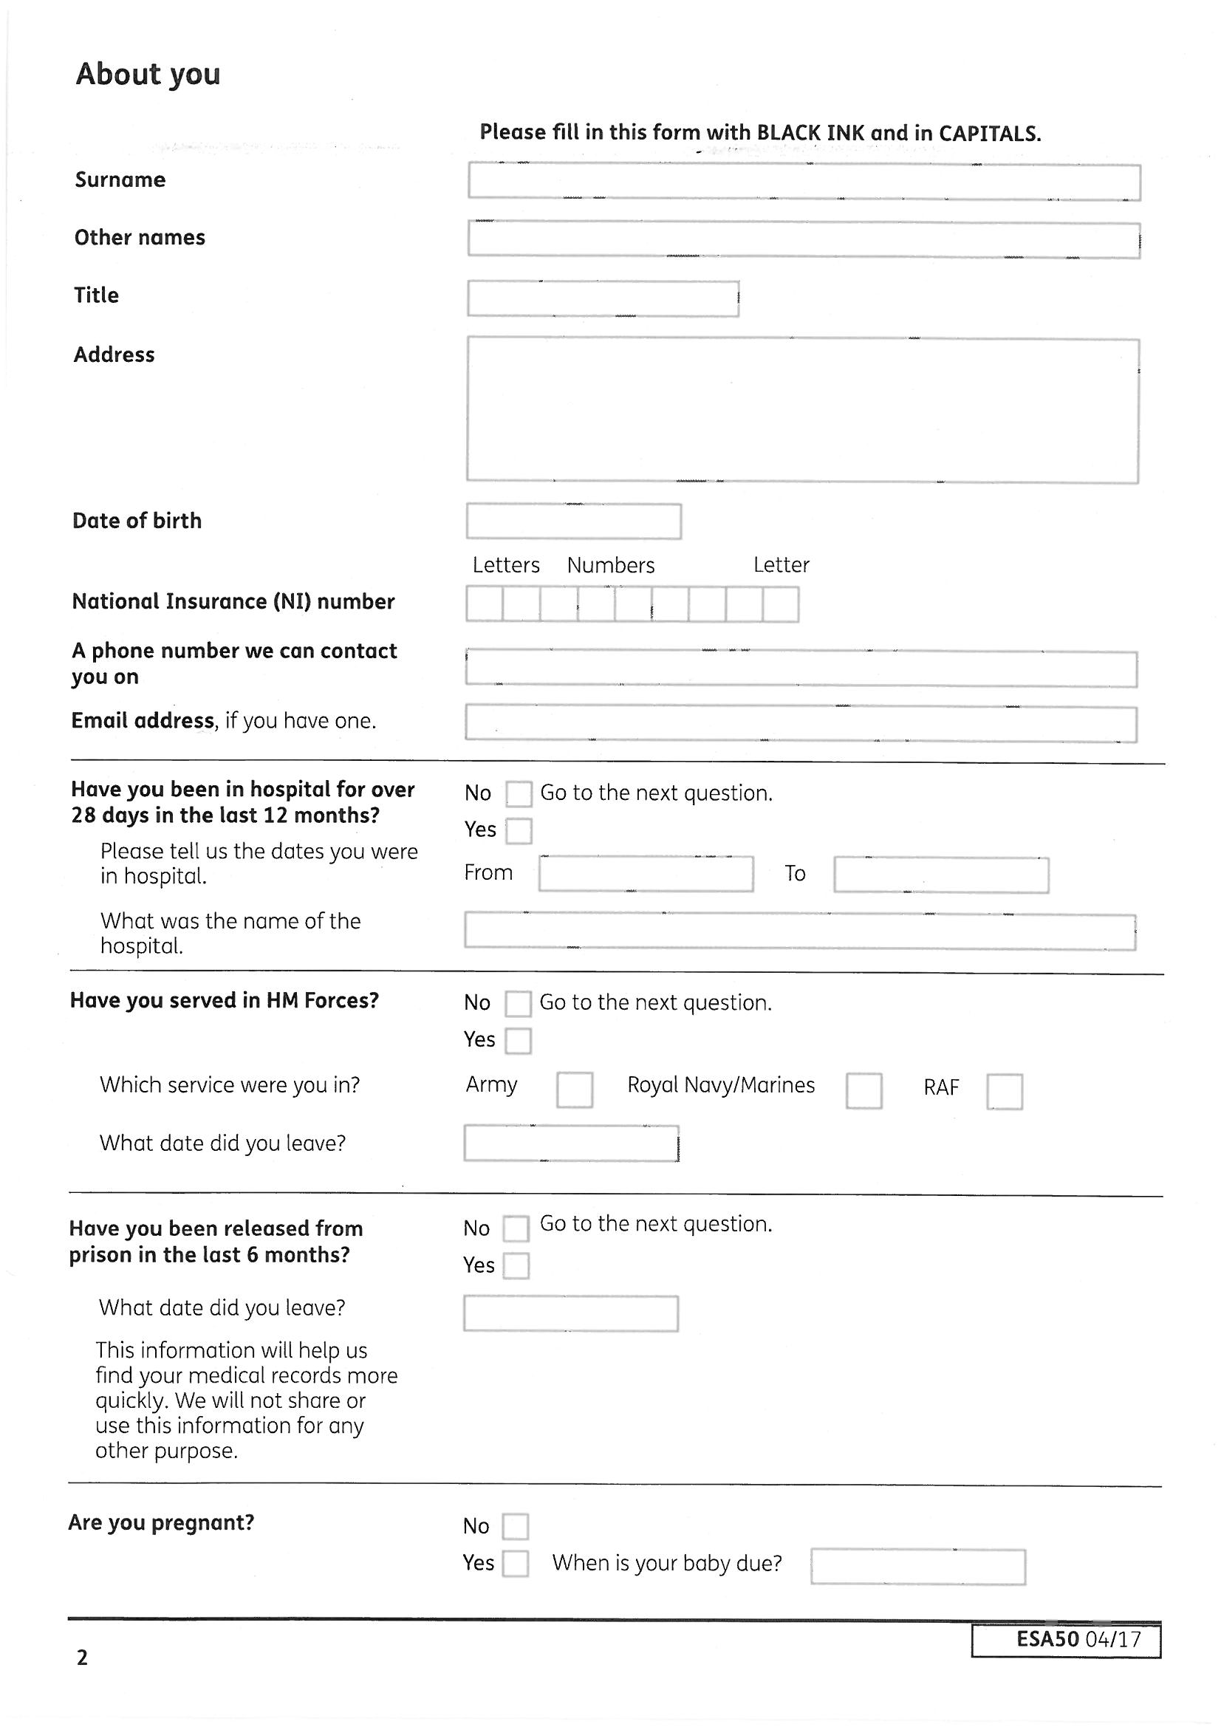
If you are over 18, after 28 days in hospital payment of any DLA or PIP stops and this stops the payment of any severe disability premium for you in your income-related ESA.
After 52 weeks payment of any enhanced disability premium and either the work-related activity component or the support component stops in both income-related and contribution based ESA. Payment of HB and housing costs in ESA also stop after 52 continuous weeks, but someone else in your house may be able to take over liability and claim instead - get advice.
Please ensure you inform ESA, DLA, PIP and HB to ensure that you do not build up an overpayment by not informing them of your changes in circumstance.

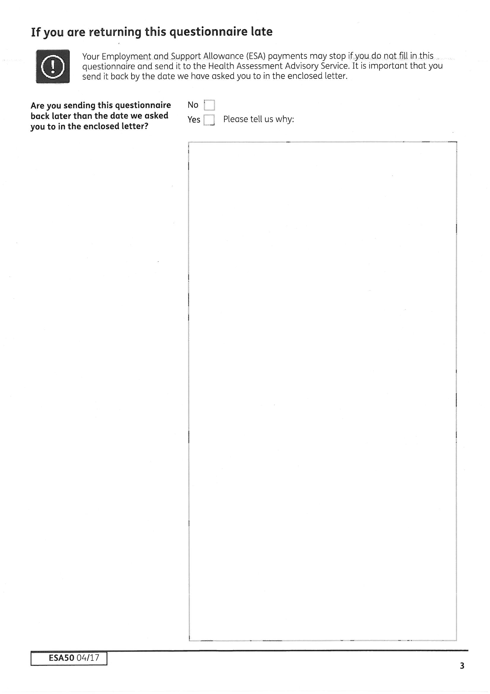

It is very important to complete and return this form by the date shown on the letter. You will be sent a reminder if you do not return the form, but if you still do not return the form within a week of receiving the reminder, you could be treated as not having limited capability for work and not entitled to payment of ESA or limited capability for work credits unless you can show good cause for not returning the form in time. The DWP should consider all the circumstances to decide whether you have good cause, including whether you were outside the country, your state of health and nature of your disability.
The DWP’s policy is NOT to stop your claim if they are aware that you have mental health or cognitive problems and instead will refer you for a face-to-face assessment. However even if this does apply to you, our advice is to still get help and complete the form—this is your opportunity to explain how your health affects you and why you meet the test. A well completed ESA50, especially if you can provide additional supportive evidence, could result in you being found to have limited capability for work (i.e. sick) without needing to attend a face-to-face assessment.
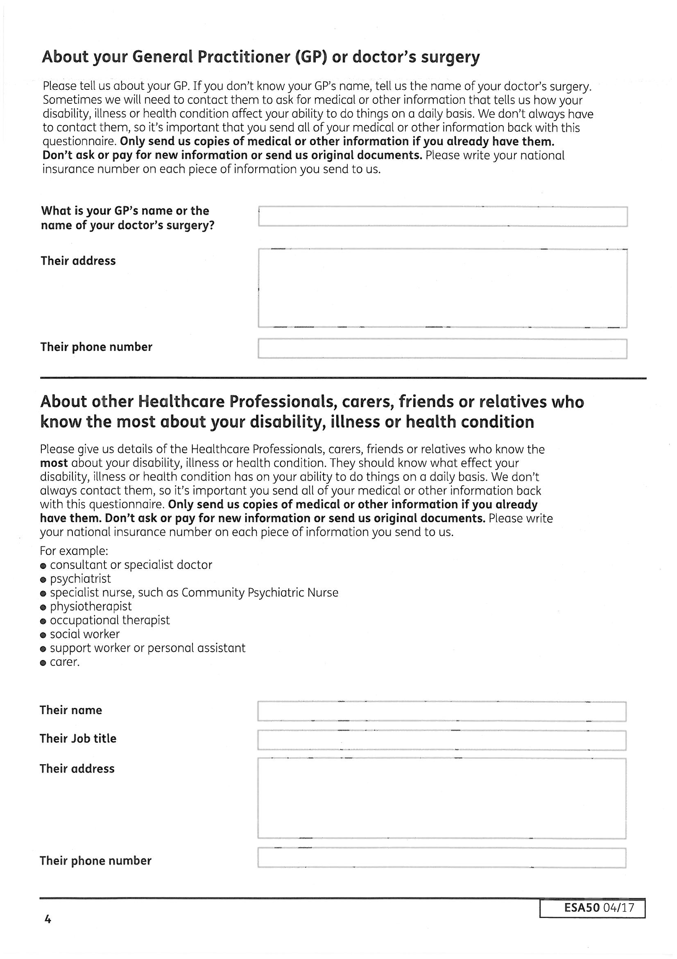
Don’t feel obliged to include details of any professionals that you do not want to be contacted — this is your claim and you are best placed to provide the details of which professional knows the most about how your health affects you.
Include details of anyone who knows how your health problems affect you, they could be your support worker, home care worker, speech therapist etc. Include more than one person if relevant.
You don't need permission to include their details but it’s a good idea to let them know in case they are asked for information.
But the best thing to do is show them this guide or a list of the descriptors and ask them to write a letter for you, explaining how the issues in the test affect you and if you think it helps explain how your health affects you, send a copy with this form.
If you see more than one GP, put down the details of the one who best understands your problems, who you have found the most sympathetic, or who you feel most comfortable with.
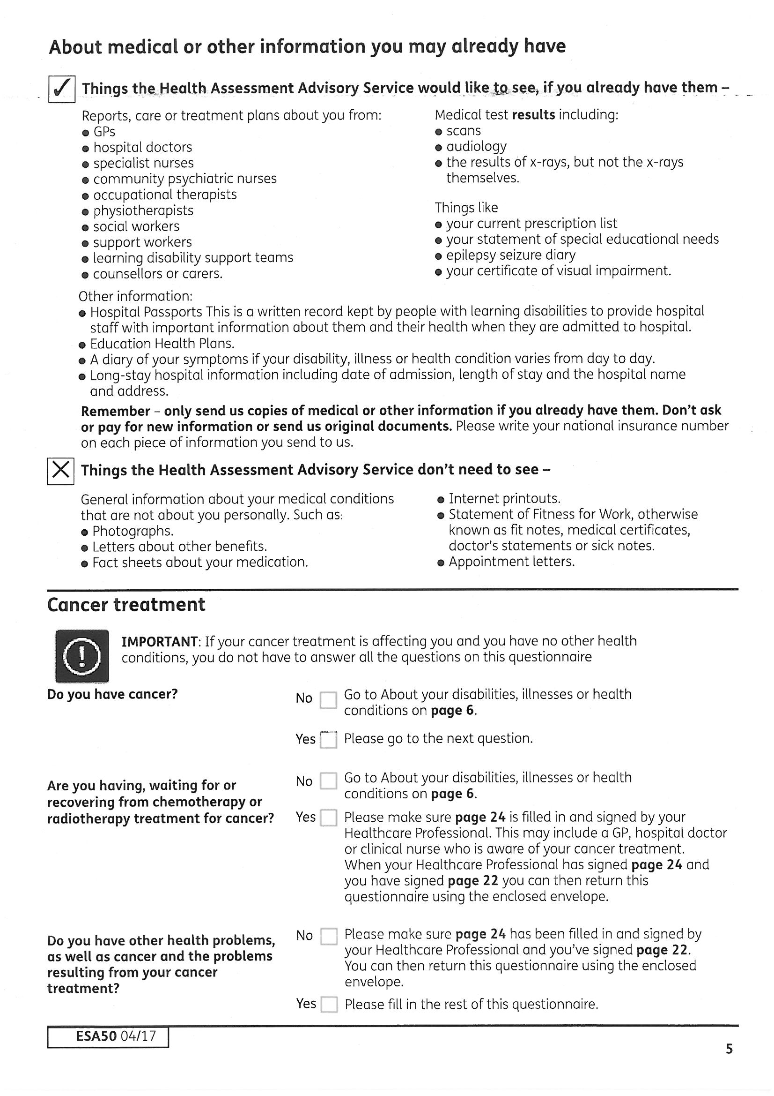
If you have evidence that shows how you meet the test include copies with the form. If you are unsure whether to include a piece of evidence - seek advice, not everything is always helpful.
This includes ALL kinds of chemotherapy or radiotherapy. It is very important to tick yes and give details if you will have it within the NEXT 6 MONTHS or if it has finished and you are still recovering - if in doubt tick yes and explain.
Because you will be treated as having capability for work and/or limited capability for work related activity given your condition and treatment it is better NOT to complete the rest of the form—just remember to get page 24 completed.
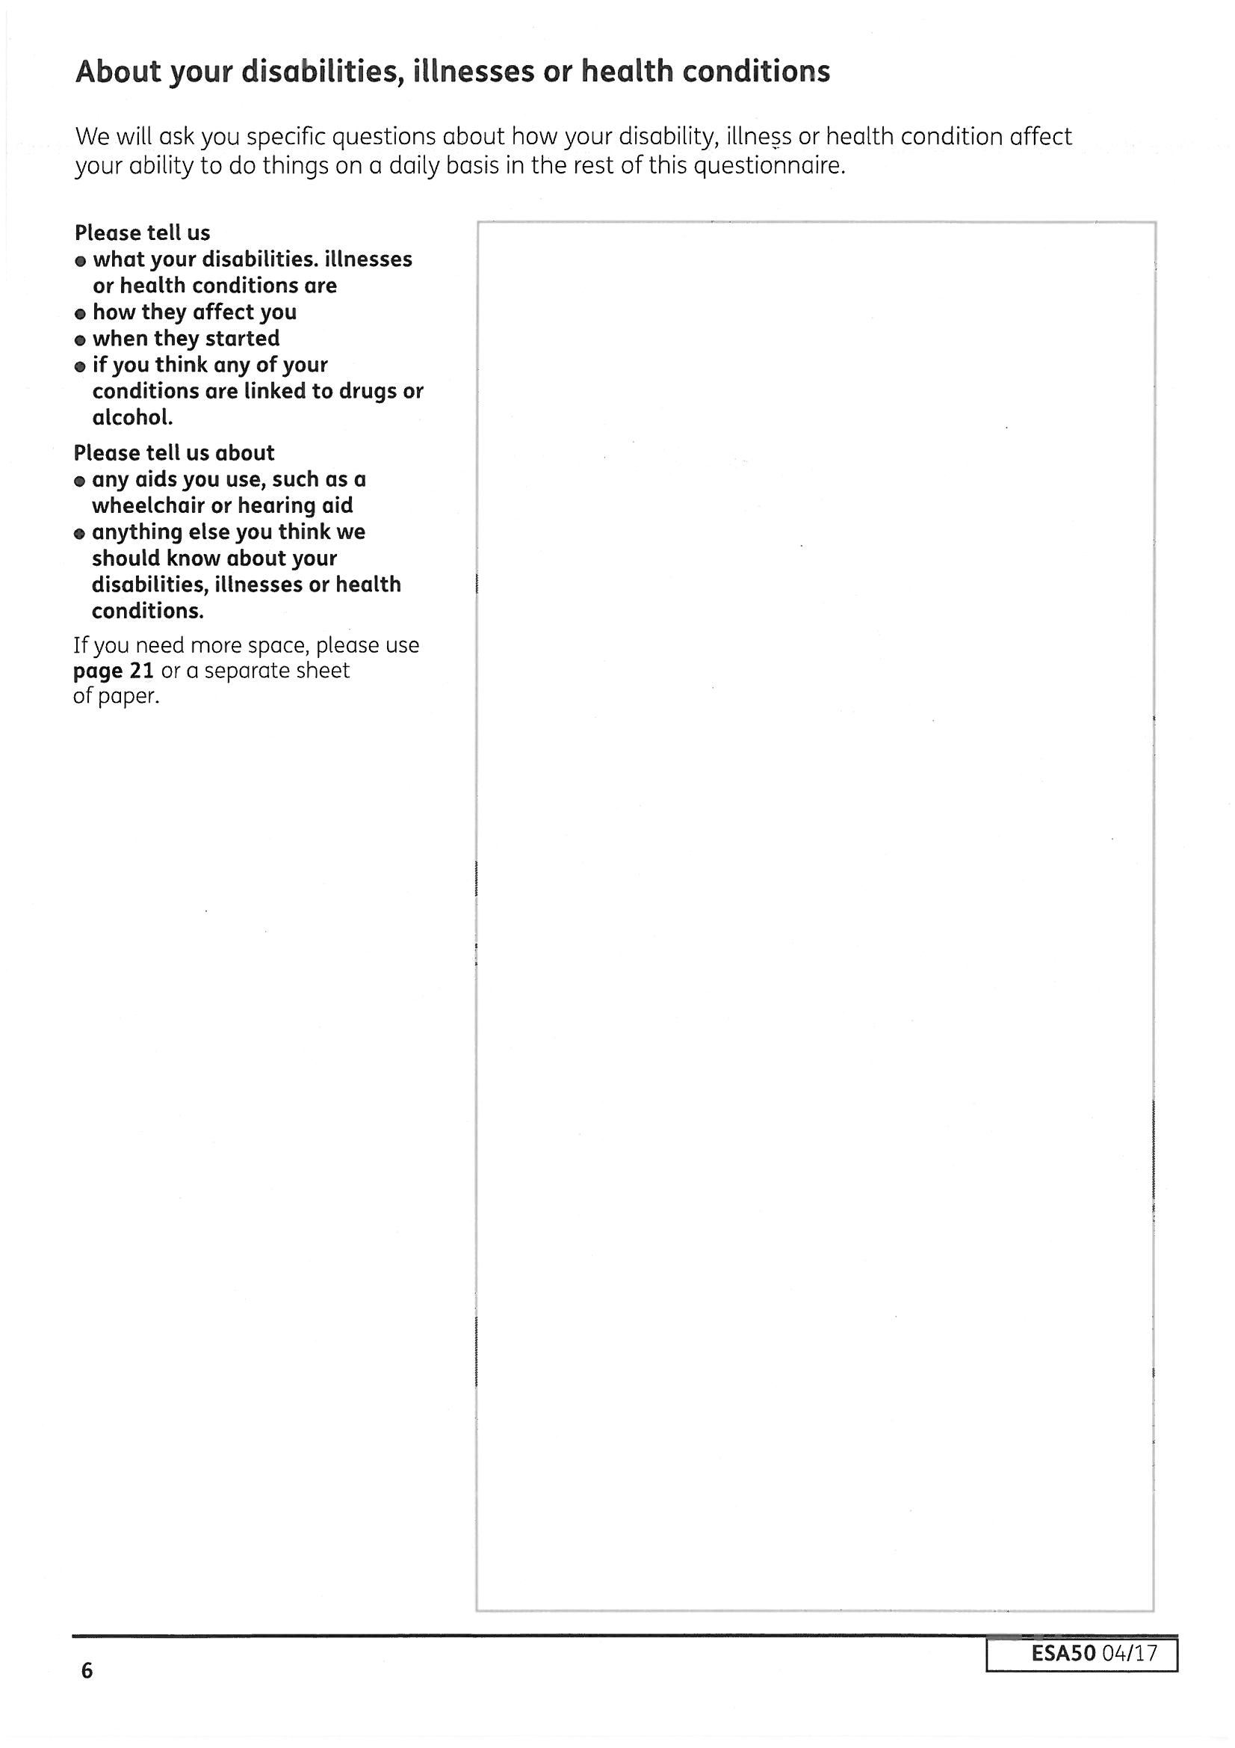
Although this page asks you to explain how your health affects you, the rest of the form gives you room to give more detail further on so you can be brief here. But do mention all your health problems/conditions and try to put an approximate date for when they started (year and approximate month/season is enough), this is all the information that is needed in this box.
Also use this page to give details of specific circumstances that mean you can be treated as having limited capability for work, but are not asked for details anywhere else on this form:
• Have been in contact with an infectious disease and given official notice not to work.
• Suffering from a life threatening uncontrolled disease.
• Pregnant and 6 weeks before your baby is born, or up to 2 weeks after birth.
• Pregnant and there would be a serious risk to your or the baby’s health if you were found capable of work.
• Are terminally ill (this means death could be possible within 6 months).
There are other treatments and situations such as certain types of radiotherapy, plasmapherisis or haemodialysis - put all the details down and get advice as you may be treated as having limited capability for work without having to score points on the test.
Explain if there would be a serious risk to your mental or physical health, or that of others, if you were found capable of work; if you had to cope with signing on for JSA or had to do a job. Eg:
• If you are attending a twelve step treatment programme for substance misuse and could not follow the programme if you were working (which could cause a relapse and damage your health or the well-being of family members).
Also use this space to explain if you are claiming income-related ESA, in full time education (but not a qualifying young person for Child Benefit) and in receipt of DLA or PIP as you should be treated as a disabled student and should be placed in the work related activity component. You should also seek further advice if you meet these conditions.
The questions throughout the form ask if you 'can' - yes box or ‘cannot' do a task - no box. 'Cannot' doesn’t mean it is impossible - it means it is too difficult, or too painful for you to do it reliably and repeatedly. ‘It varies’ does not really answer the test - they are interested in how you are "MOST OF THE TIME" so avoid ticking it varies. The decision maker may only have time to read ticks, so do tick 'No' if that is true most of the time. You can explain in the box that you have better days when you 'Can' but make sure you stress what is the norm.
IF THERE'S NOT ENOUGH ROOM IN ANY BOX , WRITE OUTSIDE IT OR ADD AN EXTRA PAGE : write your name & National Insurance number on extra pages.
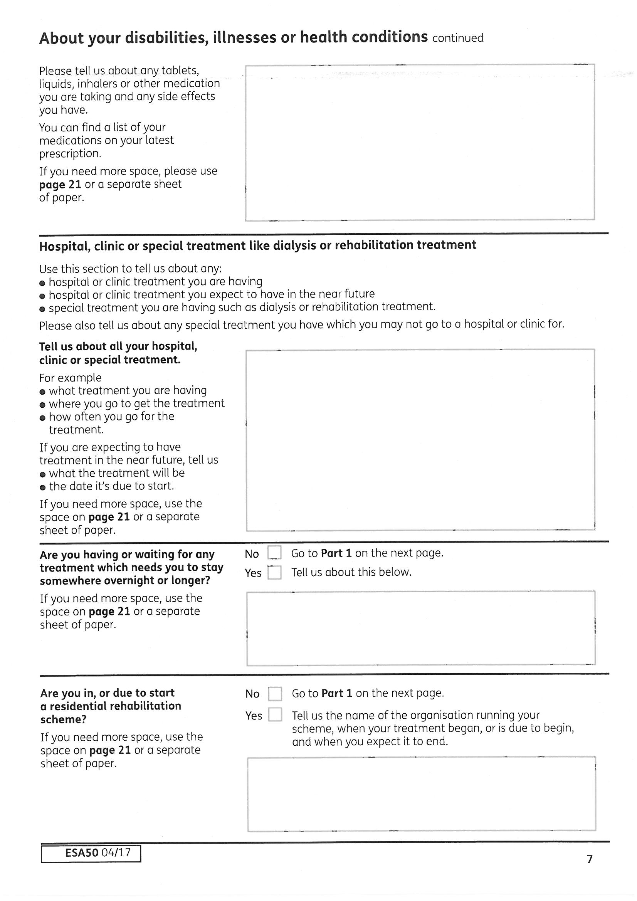
Put everything down, whether prescribed or not, even if you regularly buy it yourself - such as painkillers.
If you have side effects from any medication mention it here.
Also explain if you have stopped taking any medication because it did not work or it made you worse. This is important as your problems may be dismissed if you are not taking the expected medication if you do not explain the reasons for this, e.g: unable to take anti-depressants as it affected epilepsy medication.
It is important to give details of any residential rehabilitation programme for drug or alcohol dependency as this will mean you are treated as having limited capability for work. Do not avoid providing these details worrying about any stigma or it affecting your entitlement—the opposite is actually the case.
It is important to explain here if you are a hospital inpatient for more than 24 hours or recovering from treatment as a hospital inpatient as this means you should be treated as having limited capability for work.
If you are waiting for treatment say when you expect to have it. Give a rough date if you don't know for sure. If treatment has recently finished, say when it finished and what it was. If you are attending more than one clinic or hospital, put them all down, including attending asthma clinic, CDAT, attending hospital for regular blood tests etc, all these details will help you explain how serious your condition may be.
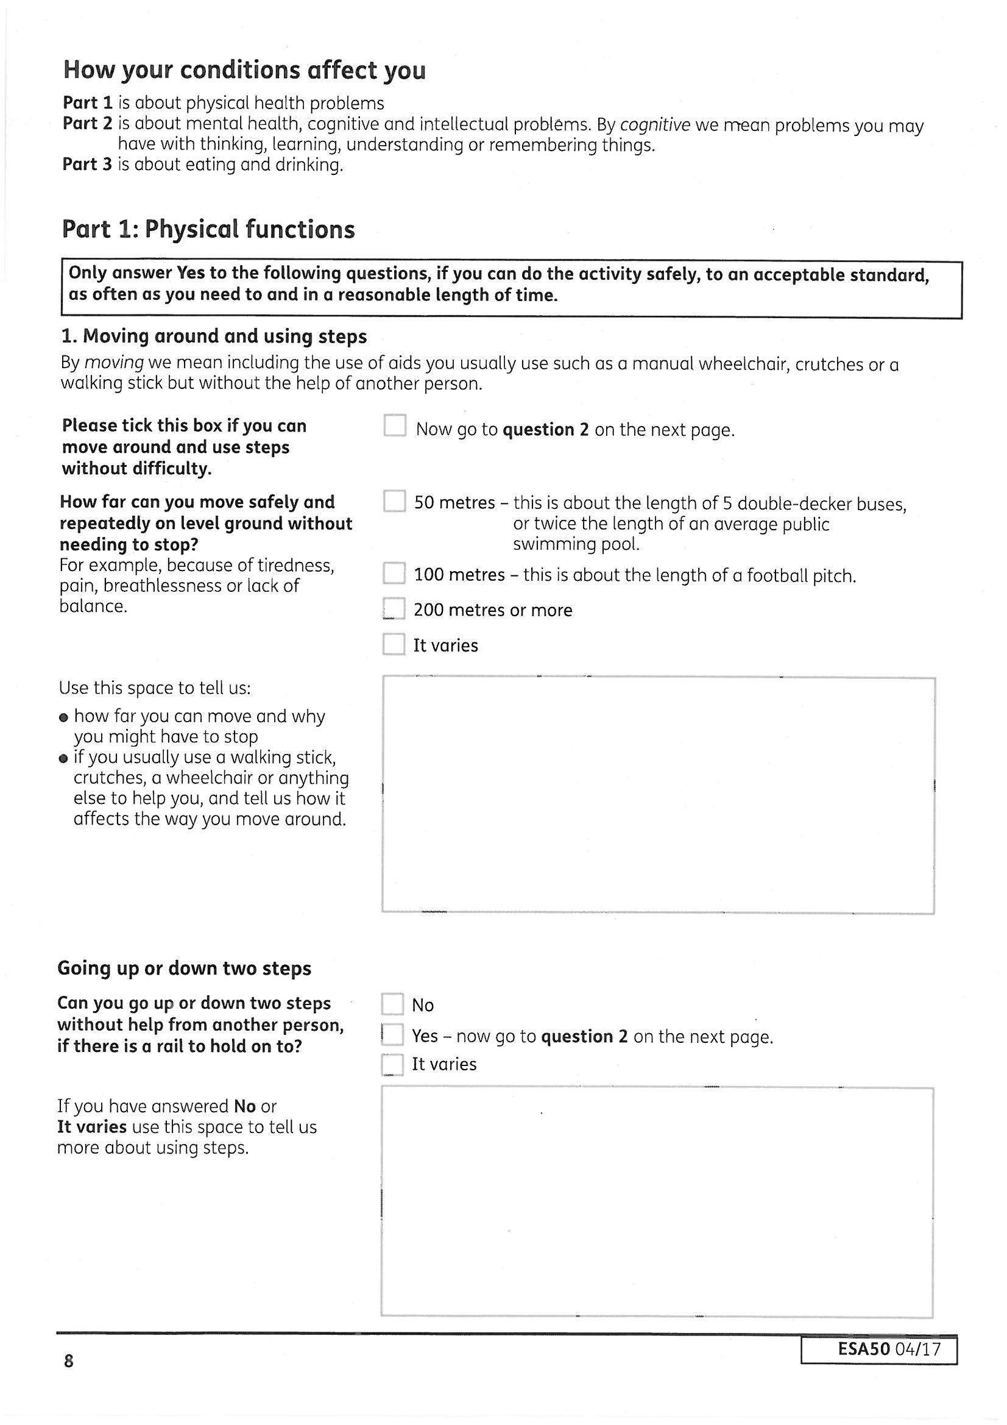
Important Note:
The form says aids ‘you usually use’ BUT the legal test is whether a walking aid, including a manual wheelchair, could reasonably be used.
Can you do this safely, reliably and repeatedly without undue pain? If you have tried and had problems give examples here. Mention any difficulties like pain, dizziness, breathlessness, numbness in feet and legs etc.
Remember ‘mobilise’ is not only walking but how far you could manage in a manual wheelchair if it was reasonable for you to use one, so explain any breathing/heart problems, limited movement in upper limbs, pain in hands etc, not just your walking problems. Would using a wheelchair instead of walking have a negative effect on your health? Consideration should be given to whether it is reasonable for you to use a manual wheelchair and how you could obtain one. The ability to store a wheelchair at home is not a consideration, because you could keep it at a hypothetical workplace, but the home environment could be relevant, eg if your wheelchair has to be kept at work, can you mobilise to get to work? It does not include mobilising in a powered wheelchair, you must be able to propel yourself.
At the medical you will be asked how you got to Grove House, so explain your journey and any problems or help you had. Did you get dropped off directly outside while your friend went to park the car? Did you have to stop due to pain walking from the bus stop? If so, how many times?
Most people are have difficulty estimating distances—can you really picture 5 double-decker buses (which are between 9.5 and 12 metres), football pitches must be between 90 and 120 metres long—when did you last play football? Think about the distance before significant (not severe) discomfort arises, not the distance you may push yourself to go. You might be able to walk 200 hundred metres but if significant discomfort starts at 25 metres, then that's how far you can walk without significant discomfort. If you carry on going despite significant discomfort or exhaustion, this should be discounted, however the HCP guidance states that ‘the end point is when the claimant can reasonably proceed no further because of substantial pain, discomfort, fatigue or distress’ - this is guidance NOT the legal test. If you need even a brief pause due to discomfort or fatigue, you have stopped.
The form does not ask you whether you can repeat the distance within a reasonable time - but this is the test so explain how long you need to rest before attempting it again. Think about whether you could manage the distance several times over the course of a working day.
Actual TEST for 1: Mobilising:
Unaided by another person with or without a walking stick, manual wheelchair or other aid if such aid is normally or could reasonable be worn or used, Cannot:
a. i. mobilise more than 50 metres - on the level - without stopping to avoid significant discomfort or exhaustion 15*
ii. repeatedly mobilise 50 metres within a reasonable timescale because of significant discomfort or exhaustion 15*
b. Cannot mount or descend 2 steps with handrail unaided by another 9
c. as for a) but 100 metres 9
d. as for a) but 200 metres 6
(* = support group descriptor)
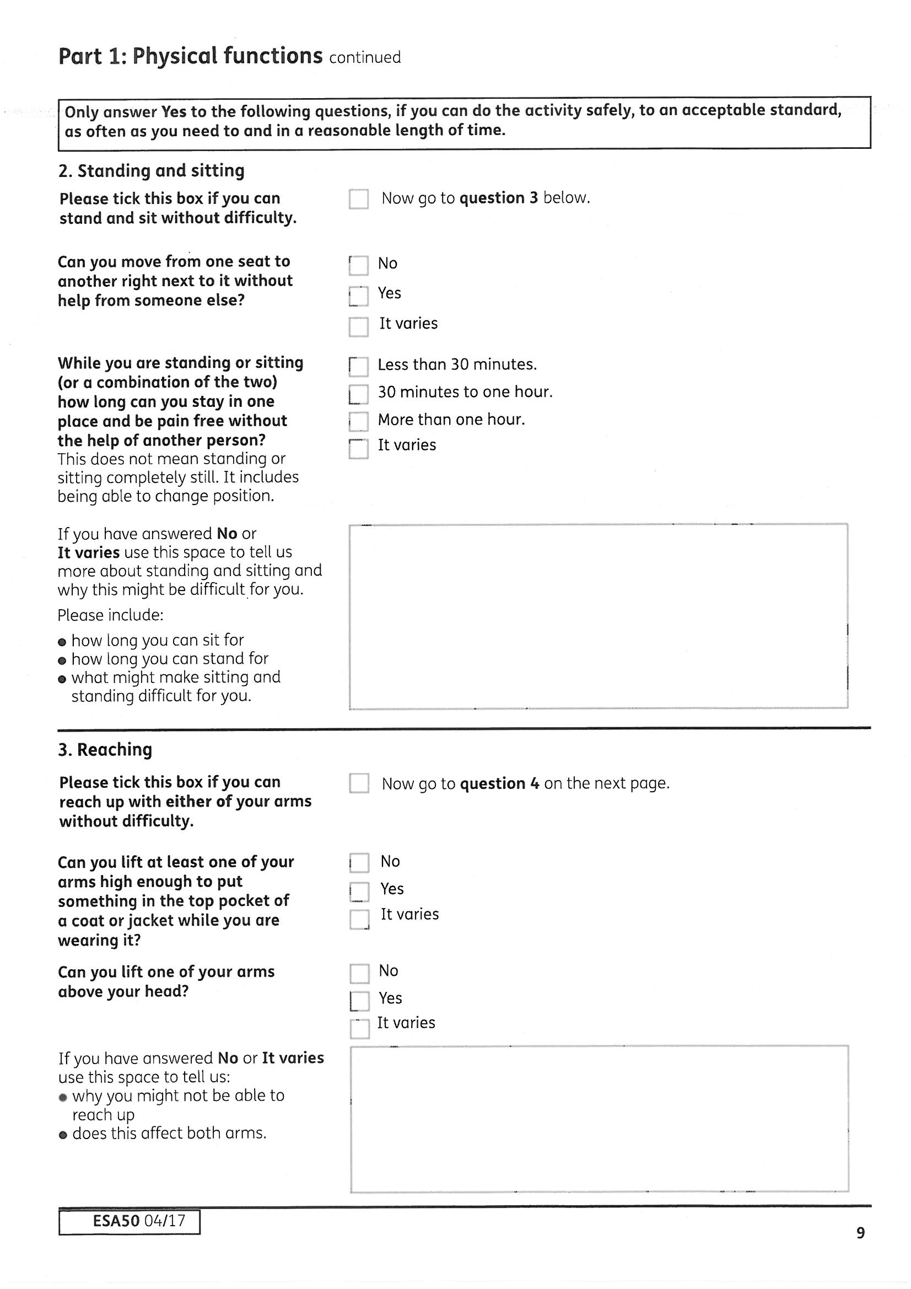
Actual TEST for 2: Standing and sitting:
Cannot:
a. Move from one seat to another alongside without physical help from another person 15 *
b. For the majority of the time remain at a work station for the majority of the time, either standing (even if free to move around) or sitting (even in adjustable chair) or a combination of the 2 - for more than 30 minutes before having to move away to avoid significant discomfort/ exhaustion 9
c. As b - cannot for more than an hour 6
Explain why moving between seats is difficult. Have you fallen or got stuck trying to move? Do you seize up after sitting for short periods, so you usually need help to move? Are you in pain? Where? Remember, not having help available doesn't alter the fact that you NEED help. This can be important for wheelchair users who, whilst mobile in the wheelchair, need help transferring.
The actual test is whether you could stay at a 'work station', like a desk or a check-out till, without needing to have a break and move away. This includes alternating between sitting and standing, you are still at the workstation if you stand up for a stretch. Having problems just sitting or just standing is not enough to score points for this activity. Explain whether you can only relieve the pain by walking around or lying down. Be careful ticking the boxes—the legal test is if cannot remain for more than an hour - the form asks if you can stay in one place for more than one hour—ticking this is like saying this activity is NOT a problem for you.
You are likely to be asked at the medical about sitting watching TV, sitting in a car or on the bus, so think about how you manage, do you have to get up in the adverts? Can you only sit with your legs elevated? Caselaw has stated that you should be able to stay at a workstation, with reasonable adjustments, in a manner which you would still be capable of doing a job, so if you can only stay there with your ‘rigidly outstretched leg’ elevated, you are not effectively remaining at a work station.
This activity looks at both arms and points can only be scored if you cannot do the descriptors with BOTH arms. If one arm is better than the other, think about and describe doing the descriptors with your better arm.
Avoid 'it varies'! Think about 'most of the time'. If you cannot put on a hat with either hand say this here - it is in the test but not on the form.
Remember 'cannot' does not mean you couldn't do it if your life depended on - it means it would cause you undue pain or discomfort, or maybe you could do it without too much problem once but could not do it again without a long break first, or that you usually cannot do it.
Give examples if you can, to explain why you have difficulty raising your arms; again you must be able to do it safely, reliably and repeatedly. E.g. ‘due to the lymphoedema following treatment for breast cancer I have been told not to reach above my head for anything’. Explain if reaching causes you shoulder or elbow pain.
Actual TEST for 3: Reaching:
Cannot raise either arm -( i.e. has to apply to both arms):
a. as if to put something into to pocket of coat/jacket 15*
b. to top of head as if to put on hat 9
c. above head height as if to reach for something 6
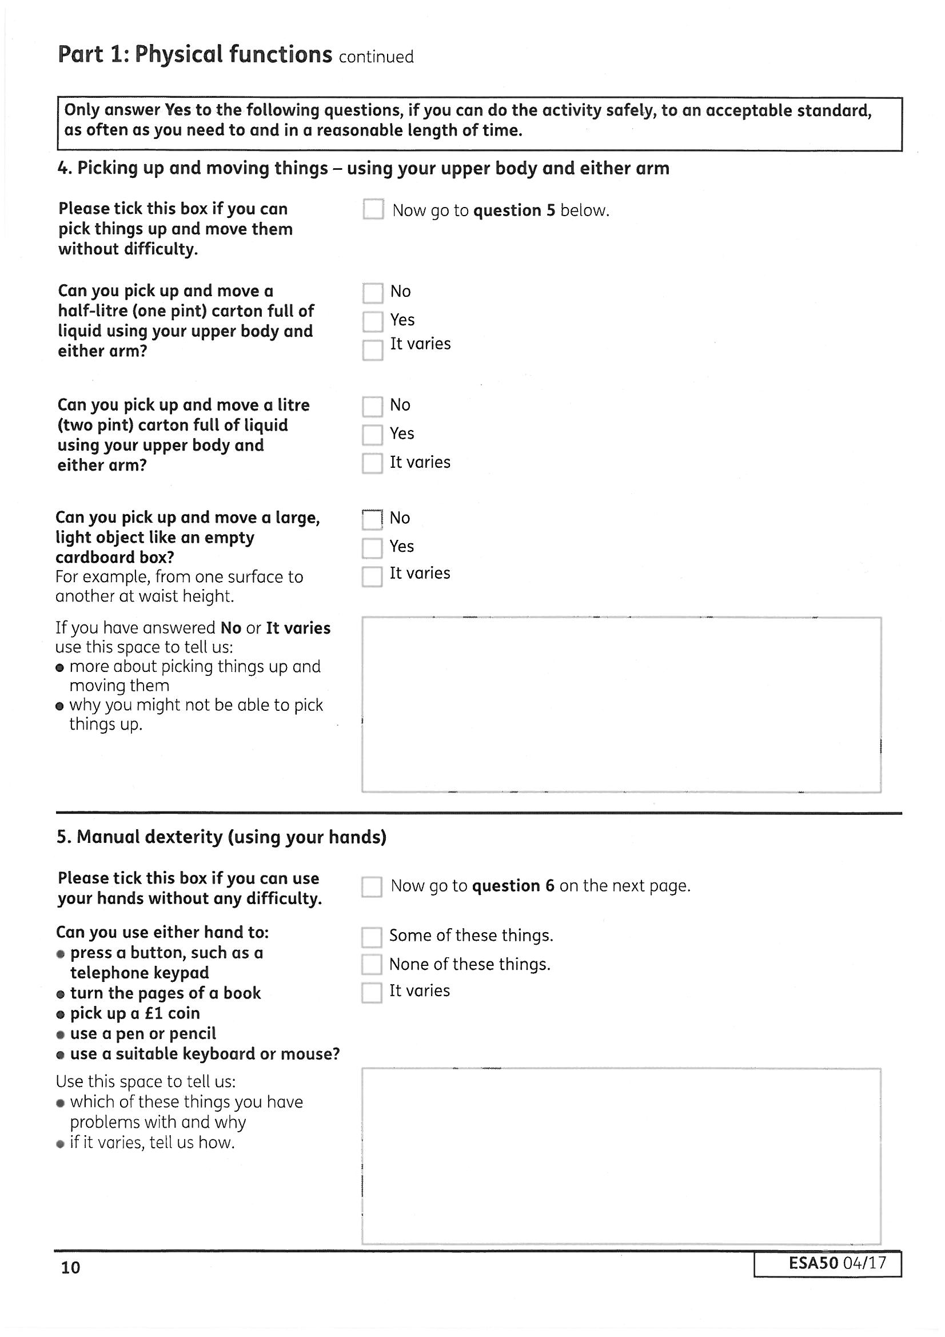
Actual TEST for 4: Picking up and moving or transferring by use of the upper body and arms
Cannot:
a. Pick up and move a 0.5 litre carton full of liquid 15*
b. Pick up and move a 1 litre carton full of liquid 9
c. Transfer light but bulky object such as an empty cardboard box 6
If you answer 'some of them', explain which ones.
If you cannot pick up a £1 coin or similar object with either hand, make this clear. It is important to make it clear that you have problems with both hands—the descriptors do NOT apply if you can manage with one hand but not the other, problems with just one hand will not score any points.
If your ability to do this varies, decide whether you can or cannot MOST OF THE TIME. If most of the time you can't, then you should say that you can't. Do not tick 'It varies' if this is the case. Pain and stiffness is relevant - mention it if it applies to you. Think about whether you could continue to do any of the actions throughout the day. Being able to do it once or twice or only being able to do it sometimes means you can't do it reliably. If you can do it a couple of times but you are then in pain for a long time afterwards and couldn't attempt to do it again, write this on the form.
A meaningful mark is not the same as writing or even signing you name—think a tick or a cross. A suitable keyboard or mouse means using an adapted keyboard or mouse with one hand, and to score points you need to not be able to use both the keyboard and mouse.
Actual TEST for 5: Manual Dexterity:
Cannot:
a. Press a button– e.g. on a phone keypad or turn the pages of a book with either hand 15*
b. pick up £1 coin or equivalent with either hand 15
c. use a pen or pencil to make a meaningful mark with either hand 9
d. single-handedly use a suitable keyboard or mouse 6
This activity does not consider whether you can bend over and pick something up off the floor or walk off carrying the object—it is only looking at whether you can pick it up and move it—think moving it across the table. You do not need to be standing. The carton is closed so whether you would spill the liquid doesn’t count.
If you only have the use of one arm you will have to explain how you cannot use your other arm to do this either. The test expects claimants to use their upper body as well as their arms - for example, holding an empty box against your side with one arm. If there is a reason why this could not be done reliably (you may drop it) and repeatedly (because it is tiring or painful) say so HERE. Include details of how lack of co-ordination, limited movement, pain, tremors etc affect your ability to pick up and move these things.
Caselaw has accepted that whilst it is possible to move the box with one arm and wedging it against your body and if you can manage this you will score no points, however it is easier with two arms and not everyone will be able to manage this activity with only one useful arm. You should explain why in your case you cannot manage this. Being able to pick up and move an empty cardboard box may in your case involve the co-ordination of both arms, so explain any problems which affect this. It may involve the use of hands, arms and shoulders. People who have problems on just one side, such as weakness on one side following a stroke, may still have difficulty. You must be able to do the activity safely, reliably and repeatedly without undue pain, so if moving your torso causes pain in your neck etc this is relevant.
Actual TEST for 6: Making self understood through speaking, writing, typing or other means normally or could be reasonably used, unaided by another person:
a. Cannot convey a simple message - e.g. the presence of a hazard 15*
b. Has significant difficulty conveying a simple message to strangers 9
c. Has some difficulty conveying a simple message to strangers 6
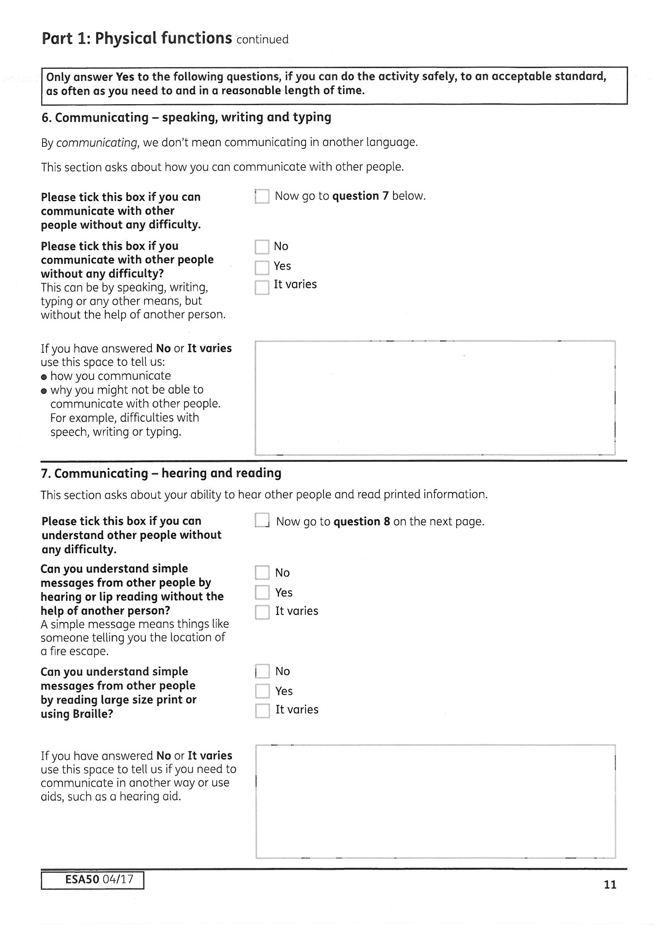
This is about understanding a simple message through the written or spoken word looking at problems with hearing and seeing. If you have partial sight or hearing, explain any problems you may have understanding fully. This is about your ability, while using your usual or any reasonable aids. If your aids cause a problem e.g. ear infections, pain, headaches or have limited use, then explain. If something doesn't seem like a huge problem and you 'manage', still include it—this could count as some difficulty. Give examples of times when you have misunderstood something written down or said, and any problem this has caused for you.
Lip reading can be easier with familiar people—but can you manage it reliably with people you do not know?
If you can see a written message but not hear it/lip read or visa versa this still counts you do not have to have problems with both to score points.
Your difficulty has to be due to a SENSORY IMPAIRMENT problems understanding other due to mental health problems or learning difficulties do not count under this activity, explain these problems under the mental health questions.
This is 16 point text and a simple message.
Therefore if this causes you difficulty and you do not understand Braille, explain it on the form. The ESA50 is available in large print or Braille, if you need the form this way - ask the DWP.
Actual TEST for 7: Understanding Communication - verbal (e.g. hearing/ lip reading) alone, non verbal - (e.g. reading 16pt print, braille) alone or a combination of the 2 unaided by another person, but with any aids, normally used, or that could be reasonably, used:
a. Cannot understand a simple message - due to sensory impairment - such as location of a fire escape 15*
b. Has significant difficulty understanding a simple message from a stranger due to sensory impairment 15
c. as b) but some difficulty 6
Could you let another person know reliably if there was a hazard, or not? Think about other examples too, like telling someone that a) somebody rang to speak to them, b) how much something costs, c) where the toilets are. Can you ask someone for something you need from them? Think about speech, writing or typing—all three, do you have the ability to pass on the message and someone else must be able to understand it. Just having speech problems is not enough, are you also physically unable to write the message. This activity looks at a combination of speech and limb/hand problems eg after a stroke. This isn't about language barriers- you won't pass the test just because you can't understand English. Communication is no good if it you can only manage it sometimes! REMEMBER this is a physical health descriptor, there is no point explaining here your problems communicating due to mental health or learning difficulties (but don’t forget to explain these problems under the mental health questions), however brain damage is physical as well as cognitive so will be relevant here.
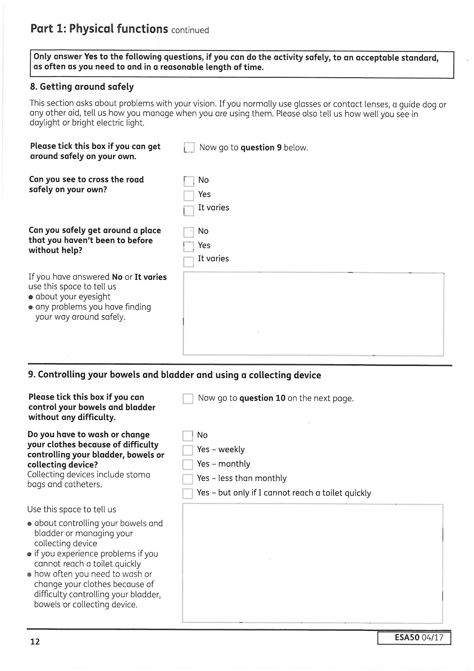
Actual TEST for 8: Navigation and maintaining safety, using a guide dog or other aid normally used, or that could be reasonably used:
Cannot - due to sensory impairment - without being accompanied by another:
a. Navigate around familiar surroundings 15
b. Safely complete a potentially hazardous task such as crossing a road 15
c. Navigate around unfamiliar surroundings 9
If the problem is variable—tick the box that is most accurate for the majority of the time. Do not end up not correctly in the support group because occasionally it does not happen every week but most of the time it is weekly. If it is less than monthly, are you still at risk of not getting there on time the majority of the time. Do not play the problem down due to embarrassment.
Actual TEST for 9: Absence or loss of control whilst conscious leading to extensive evacuation of the bowel or bladder, - other than enuresis - despite wearing/use of aids/ adaptations normally or that could reasonably be used:
a. At least once a month (* if weekly, Support Component) experiences:
i. Loss of control leading to extensive evacuation of the bowel/ voiding of bladder; or
ii. substantial leakage from collecting device sufficient to require cleaning & change of clothes 15
b. The majority of the time is at risk of loss of control leading to extensive evacuation of the bowel/ voiding of bladder, sufficient to require cleaning & change of clothes, if cannot reach a toilet quickly 6
This is a very personal question, but it is important to go into detail. If it is 'less
often' say how often roughly. If you are at risk of losing control if you are not
able to reach the toilet quickly enough, make this clear. Say if there is no way of
knowing when this will happen and remember that you are talking about your
bowel AND/OR bladder. By including ‘whilst conscious’ in the wording of the test it does not apply to losing control during an epileptic fit, sleeping or whilst unconscious for other reasons. Mobility problems may make you unable to reach the toilet quickly enough, but this needs to be linked to an element of bladder/bowel control issues as well.
Do not worry about whether you have had extensive evacuation/voiding, the test is that it is sufficient enough to require cleaning and a change of clothes—if you need to do this then it was extensive. If you are unable to use pads or they do not provide sufficient protection explain that here. Decision makers can decide that if you don’t use pads it is not really a problem, so explain why you are unable to eg causing soreness.
Do you need another person with you to be safe outside because of a sight or a hearing problem? The legal test does not include vision only so if your hearing problems mean you meet the descriptors this legally counts and so explain this here, although in reality hearing problems are only likely to be an issue here if combined with visual problems. (If you have mental health problems affecting your ability to go out alone, don’t mention them here, there are relevant questions later in part 2.)
Explain problems in familiar places if you have them, as well as in unfamiliar places where you do not know what to expect or what might be in the way. Explain any problems with different light levels or time of day has on your vision.
Do you have problems crossing roads, e.g. due to a lack of peripheral vision, or problems judging distances? Give examples of difficult or dangerous things that have happened when out and about—explain any near misses. Not all roads have safe crossings, so explain this and how it causes problems in both familiar and unfamiliar places. If you cannot see well enough to find your way somewhere unfamiliar can you really see well enough to safely cross the road? Explain why having another person makes it possible (or less risky) for you to be outside - describe what they do that makes you safer while out and about. Think about other hazards as well eg walking along a country lane without a footpath, walking around a shop or workplace with obstacles, walking along a crowded pedestrian route, caselaw has confirmed it is not just crossing roads.
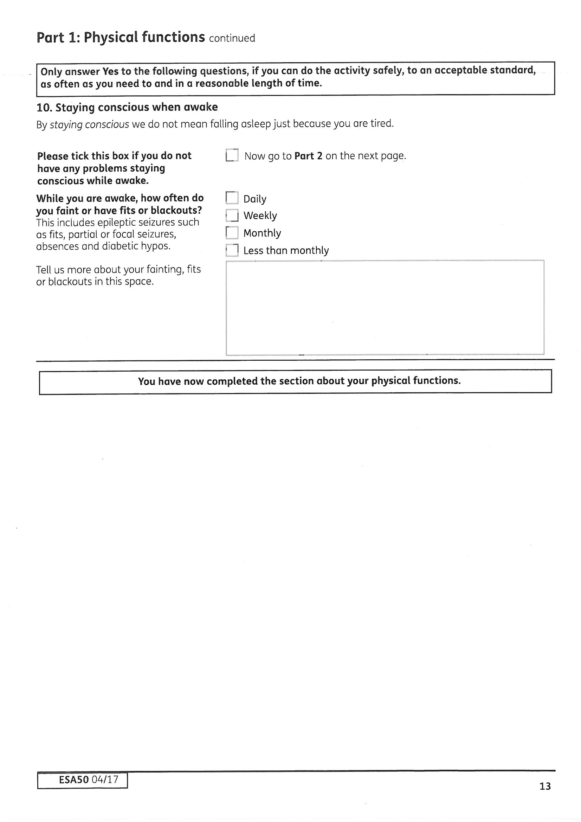
Actual TEST for 10: Consciousness during waking moments:
Has an involuntary episode of lost/ altered consciousness resulting in significantly disrupted awareness or concentration:
a. At least once a week 15
b. At least once a month 6
Remember legally it is not just faints, fits or blackouts—altered consciousness not just lost consciousness is part of the legal test. If you are diabetic and your sugars are too high or low you may still be conscious but unsafe due to confusion or reduced awareness. ‘Absences' count, too. You may not have a full fit - your eyes may be open and it may only last for a few seconds, but if it affects your concentration enough for it to cause you a problem, explain this.
If you have had any accidents or near-misses because of this, you should detail what they are. For example, if you've been outside and had a fit or an absence, have you been unable to concentrate on traffic? Have you been cooking when this has happened? Explain how disorientated you feel and how long it takes to recover afterwards as this will continue to disrupt awareness and concentration even after you have regained consciousness.
Remember having enough warning to sit down in your own house does not mean the episode has not caused significantly disrupted awareness or left you unable to function while you recover. Ask your family and friends if they have noticed absences that you are not aware of.
Falling asleep because of ‘natural tiredness’ in the day is not losing consciousness during waking moments and therefore does not count. However caselaw law has stated that this would not be true in the case of narcolepsy or severe medication induced drowsiness if it is severe enough to amount to or result in an involuntary episode of lost or altered consciousness resulting in significantly disrupted awareness or concentration.
The HCP guidance states that migraines do not usually result in a ‘significant loss of consciousness in most cases’, with the exception of rare basilar type migraines. This is not legally correct as it ignores ‘altered consciousness’ and if, due to an aura or increased sensitivity to light and/or sound in your case causes you to experience altered consciousness which significantly disrupts your awareness or concentration then it may count and you should explain here.
This activity is part of the physical test and therefore altered awareness due to non physical reasons eg panic attacks will not count.
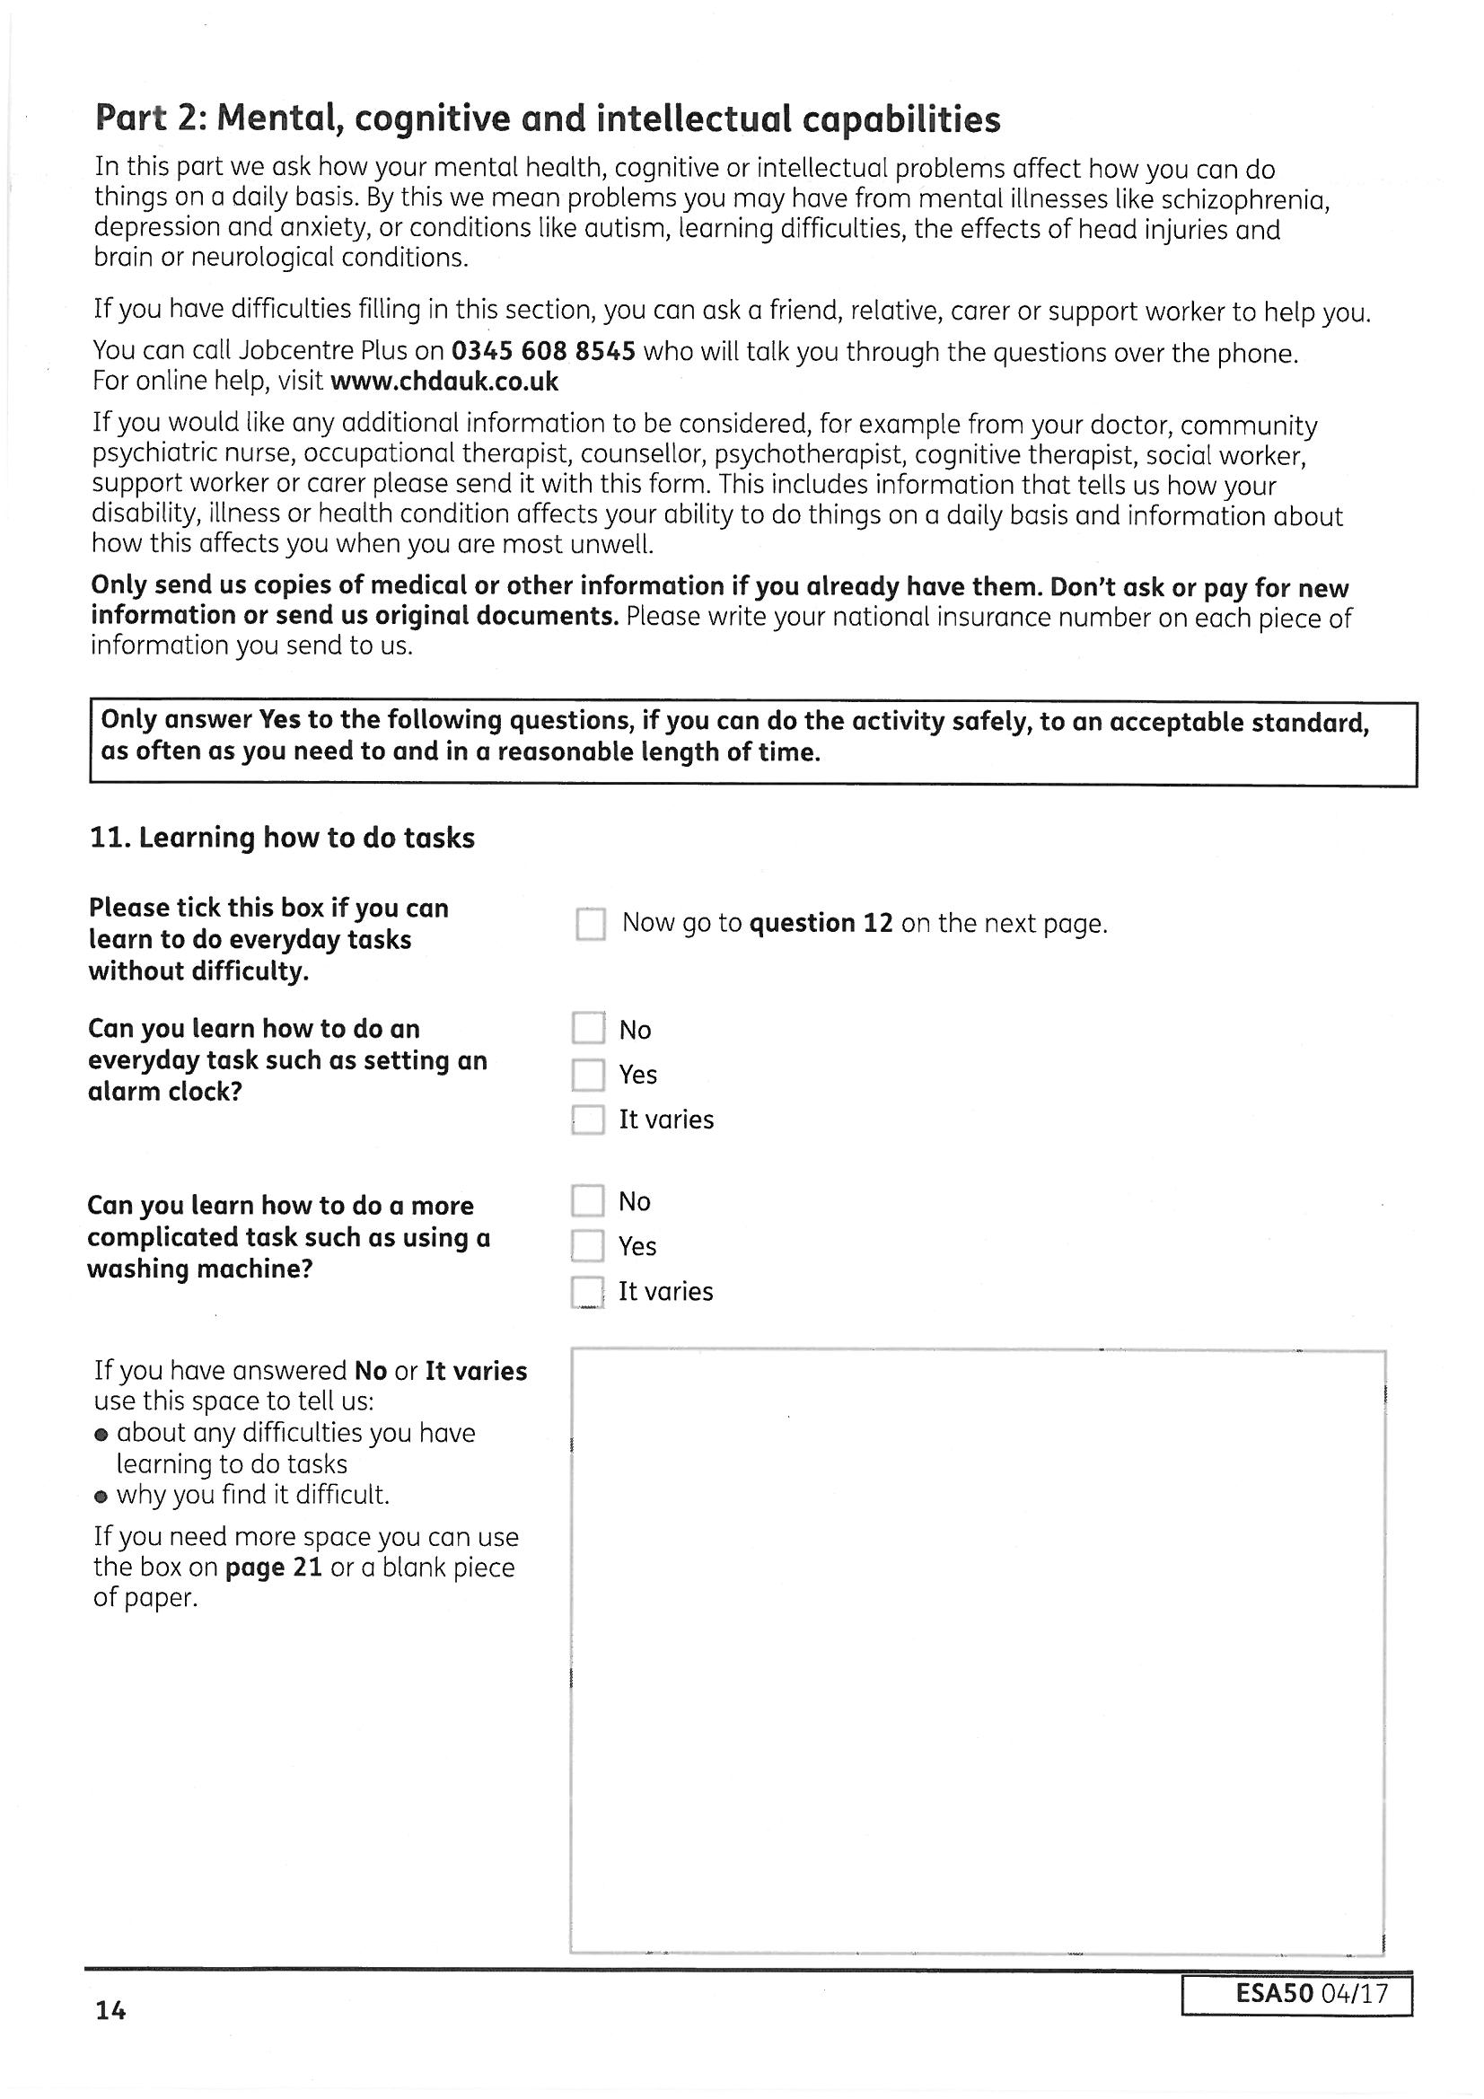
The HCP guidance says this is may be relevant to conditions such as learning difficulties or brain disorders such as brain injury or stroke. The guidance says that people with ‘severe and profound learning disability’ are unlikely to be able to learn how to complete a simple task and people with ‘moderate learning disability’ are unlikely to learn a moderately complex task.
But also consider any mental/cognitive condition that affects the ability to learn, concentrate and remember. Depression can cause problems with memory and concentration, so learning how to do a new task, e.g. working a new mobile, becomes difficult.
What is meant by ‘BEYOND a moderately complex task’? The guidance says a simple task involves 1 or 2 steps and a moderately complex task involves 3 or 4 steps – this is only a guide. Use examples. What have you have struggled to take in and learn to do? If you have learned how to do something one day but are unable to remember how to do it the next day, you have NOT learned how to do the task.
The length of time it takes to learn a NEW task is also important, you should be able to learn how to do something in a reasonable length of time, not eventually, after intensive input.
The test is about the capability to work, think about tasks that may be needed to learn in a workplace, as the guidance states ‘within the workplace, the ability to learn tasks is vital’.
Actual TEST for 11: Learning Tasks:
Cannot:
a. Learn how to do a simple task, such as setting an alarm clock 15*
b. Learn anything beyond a simple task such as setting an alarm clock 9
c. Learn anything beyond a moderately complex task, such as steps involved in operating a washing machine to clean clothes 6
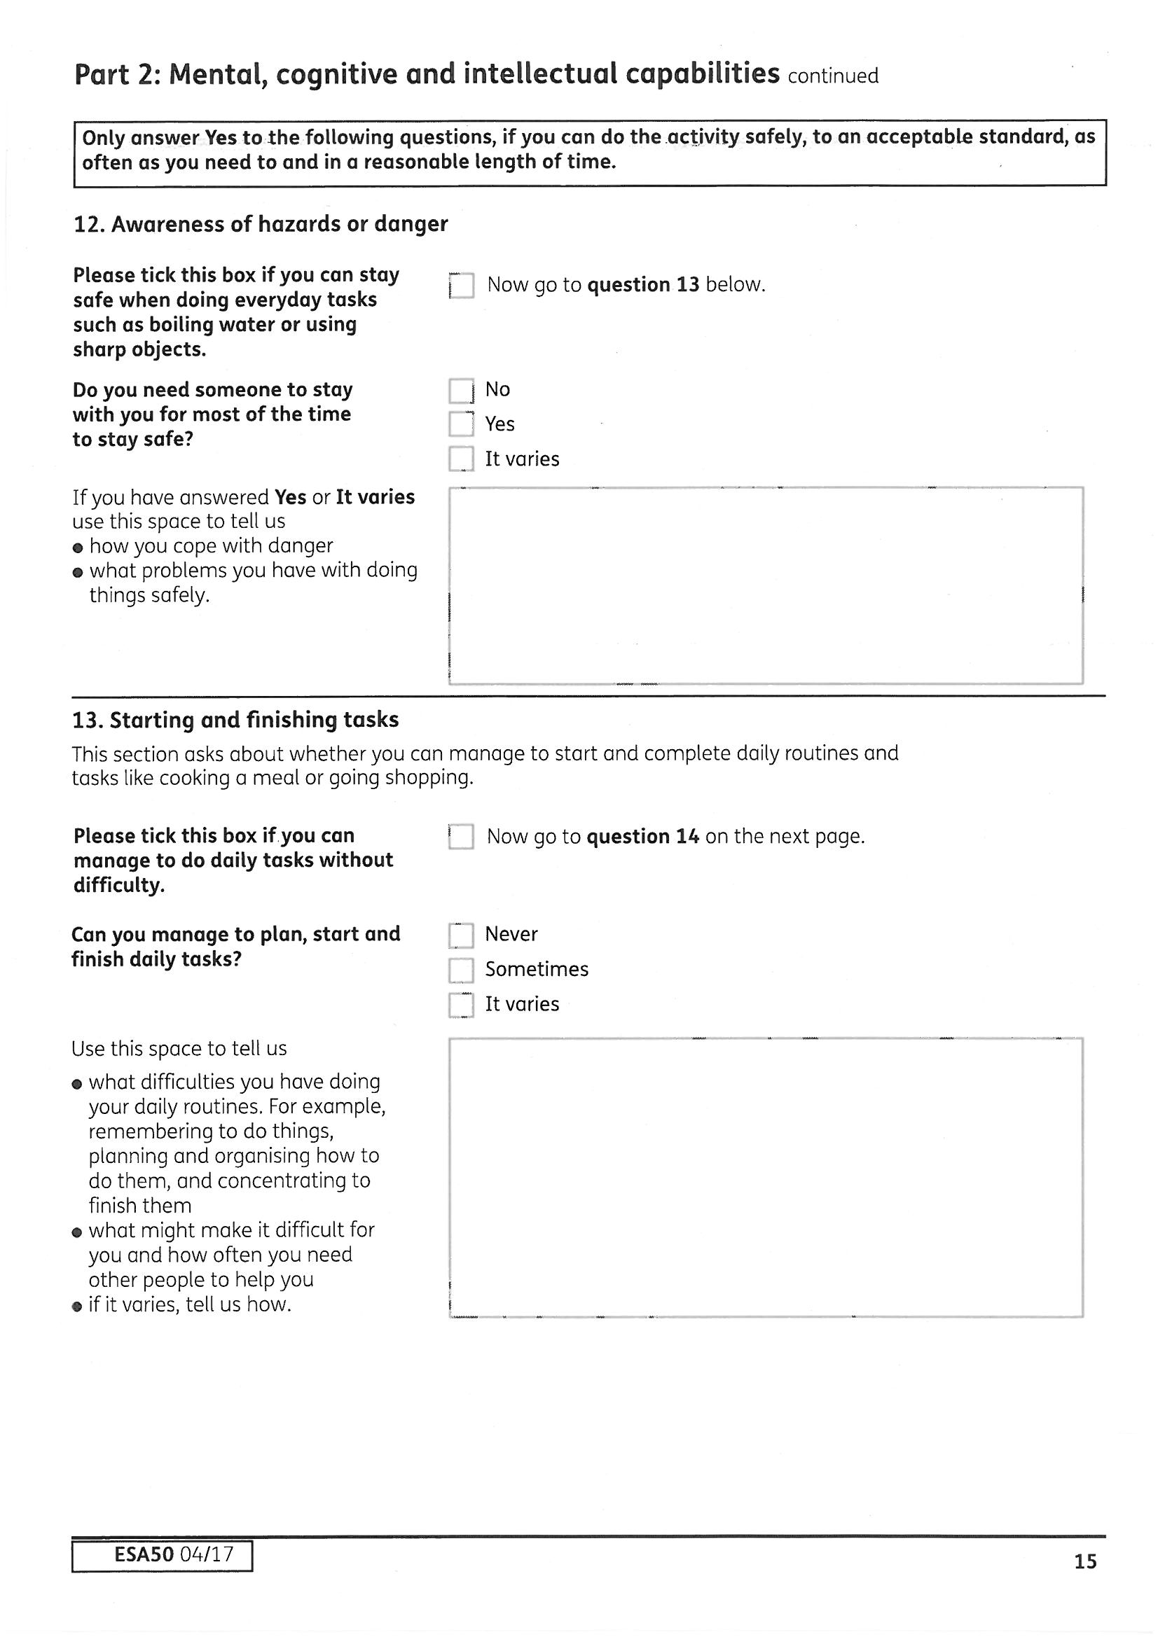
Actual TEST for 12: Awareness of hazards (such as boiling water or sharp objects)
Reduced awareness of everyday hazards leads to a significant risk of (i) injury to self or others, or (ii) damage to property or possessions, requiring supervision to maintain safety:
a. for the majority of the time 15*
b. frequently 9
c. occasionally 6
This is both starting and successfully completing at least 2 tasks in a row, in a logical order, such as planning and cooking a meal—without needing to be prompted by someone else. If you can only do things with encouragement, then the answer is ‘never’ - use the box to explain about the encouragement you need.
The HCP guidance says this applies to people with conditions such as psychosis, Obsessive Compulsive Disorder (OCD), autism, learning disability, very severe depression causing apathy or abnormal levels of fatigue. Remember this is guidance only and if it affects you in any way, write it down. Even ‘mild’ depression can result in you being unable to get started on anything without encouragement, so should be included.
If you suffer from OCD and would not be able to finish a task in a reasonable time, you should not be considered to have successfully finished. Explain what rituals you have to do and how long everything takes.
Caselaw has now stated that activities that are automatic such as automatically getting dressed is not sufficient as it does not involve the legal test of action involving planning, organisation, problem solving, prioritising or switching tasks. Give examples of activities you cannot start and finish that actually reflect the test. Think about planning, preparing and then cooking a meal (instead of putting anything to hand in the microwave), going shopping—making a list, deciding where to go, choosing what to get instead if can’t get what is on your list or getting dressed - not just in what is left out, choosing appropriate clothes, deciding if they need washing or ironing, switching to ironing before getting dressed.
The guidance and ESA50 form have been updated to reflect the caselaw.
Actual TEST for 13: Initiating and completing personal action (which means planning, organisation, problem solving, prioritising or switching tasks)
Cannot - due to impaired mental function reliably initiate or complete at least 2 sequential personal actions
a. always 15*
b. most of the time 9
c. frequently 6
Give details of anything that causes reduced awareness or puts you at any risk, including leaving the oven on due to lapses in concentration. This could be caused by learning difficulties, conditions affecting concentration, brain damage, neurological conditions that affect awareness eg dementia. It could also include people with severe depression and psychotic disorders that reduce attention and concentration. If it varies explain why e.g. when in manic phase of bi-polar disorder you have no concept of risk.
The HCP guidance states that ‘the majority of the time’ means needing daily supervision, and ‘frequently’ means several times a week – this is guidance only and has no basis in law.
The questions for this activity on the form bear little resemblance to the actual descriptors, without knowing the test how would you be aware that occasional lack of awareness due to mental health or cognitive impairment would count?
It is not just boiling water, the guidance gives other examples: road safety awareness, driving, ability in the kitchen, electrical safety awareness, responsibility for children or pets. Remember to think of whether supervision for safety would be needed in the workplace, not just at home which may have been adapted to mitigate any risks.
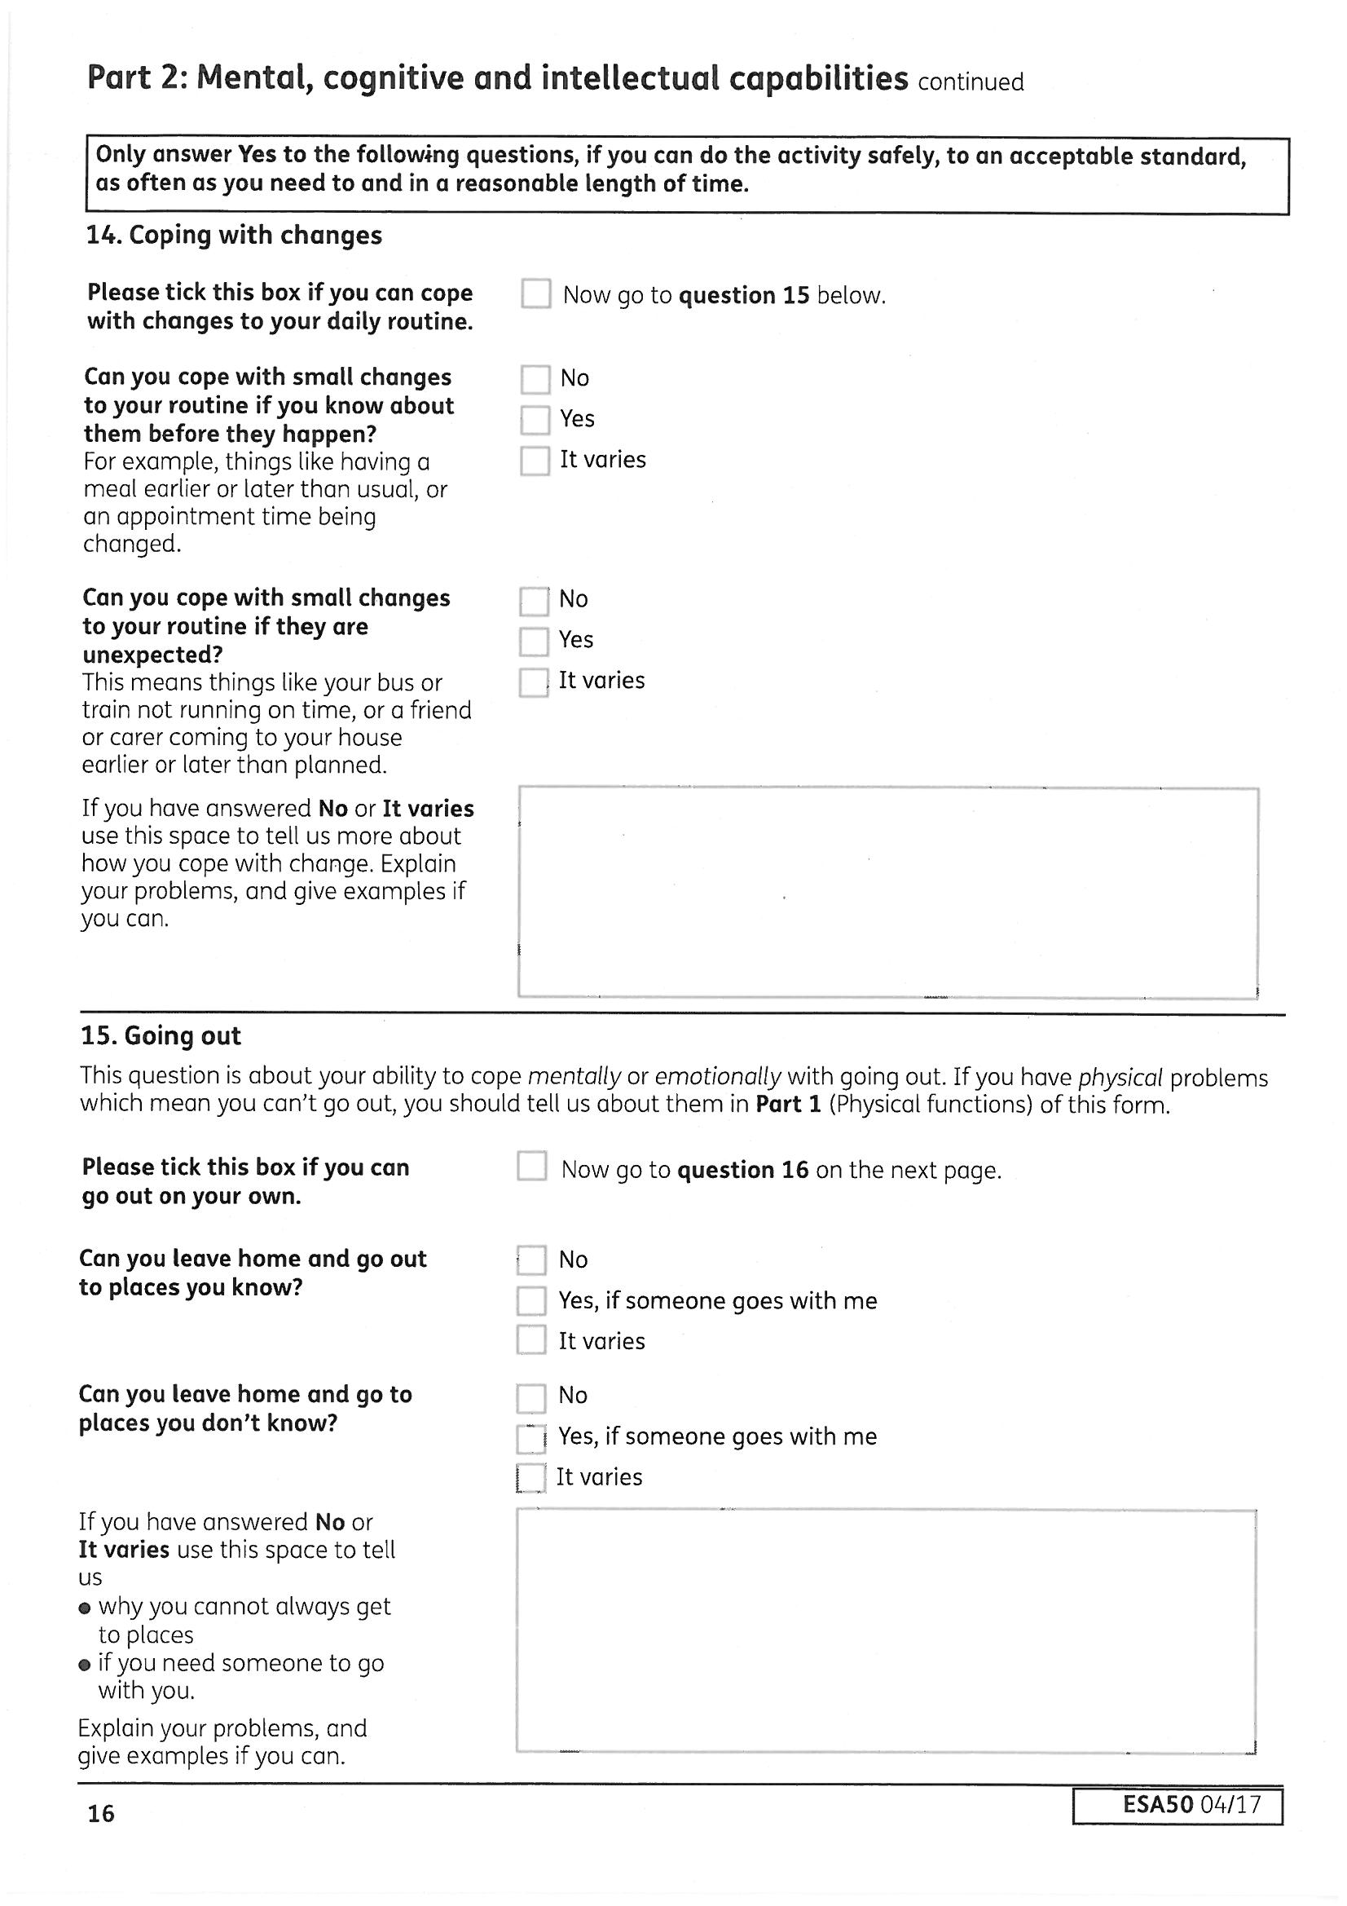
Actual TEST for 14: Coping with change
Cannot:
a. Cope with any change to the extent that day-to-day life cannot be managed 15*
b. Cope with minor planned change - such as pre-arranged change to routine time scheduled for lunch break to the extent that day to day life is made significantly more difficult 9
c. Cope with minor unplanned change (such as the timing of an appointment on the day it is due to occur) to the extent that day to day life is made significantly more difficult 6
Actual TEST for 15: Getting About
a. Cannot get to any place outside the claimant’s home with which the claimant is familiar 15
b. Cannot get to a specified place with which the claimant is familiar without being accompanied 9
c. Cannot get to a specified place with which the claimant is unfamiliar without being accompanied 6
The HCP guidance lists disorientation, agoraphobia and learning difficulties as relevant here. The guidance states that descriptor A ‘represents a complete inability to leave the home’. Caselaw has clarified that this does not mean not beyond the front door at all, you can still put the bins out, but whether you can go further than the ‘immediate vicinity’ of home.
For people suffering from anxiety, panic disorder or agoraphobia the guidance states that evidence of severe anxiety (not lesser degrees of anxiety) is needed. However, lesser degrees of general anxiety could result in not being able to cope going to an unfamiliar place, so explain how you are affected and what symptoms of anxiety or panic you experience.
Consider safety issues and disorientation. For example if you experience panic attacks, do you run across roads to get away? Do you become disorientated and need help to get where you were going? If memory problems mean you get lost in either familiar or unfamiliar places, explain this. At the medical, make sure the healthcare professional is aware that you did not make it to the appointment on your own, or they will consider that you don’t have a problem in this area.
Caselaw has stated you can be accompanied by a taxi driver if the driver was essential or important in getting you there eg not getting lost or for reassurance, so explain how they help.
This is not about disliking change, but the inability to cope with it, resulting in, for example, not being able to do anything for the rest of the day, anxiety / panic attack, angry outbursts, etc.
Explain how you have coped when your support worker has had to change the time of an appointment or the bus didn’t come. If you cannot cope with change most of the time tick NO rather than It varies and then explain. Not being able to cope with any change does not mean NEVER - caselaw has confirmed it means for the majority of the time you cannot cope with change whether planned or unplanned.
The HCP guidance says this would probably not apply to anyone who has managed to attend their medical alone and coped with the assessment, so if you do feel the need to take someone with you, make sure the assessor is made aware of the reasons they have come with you.
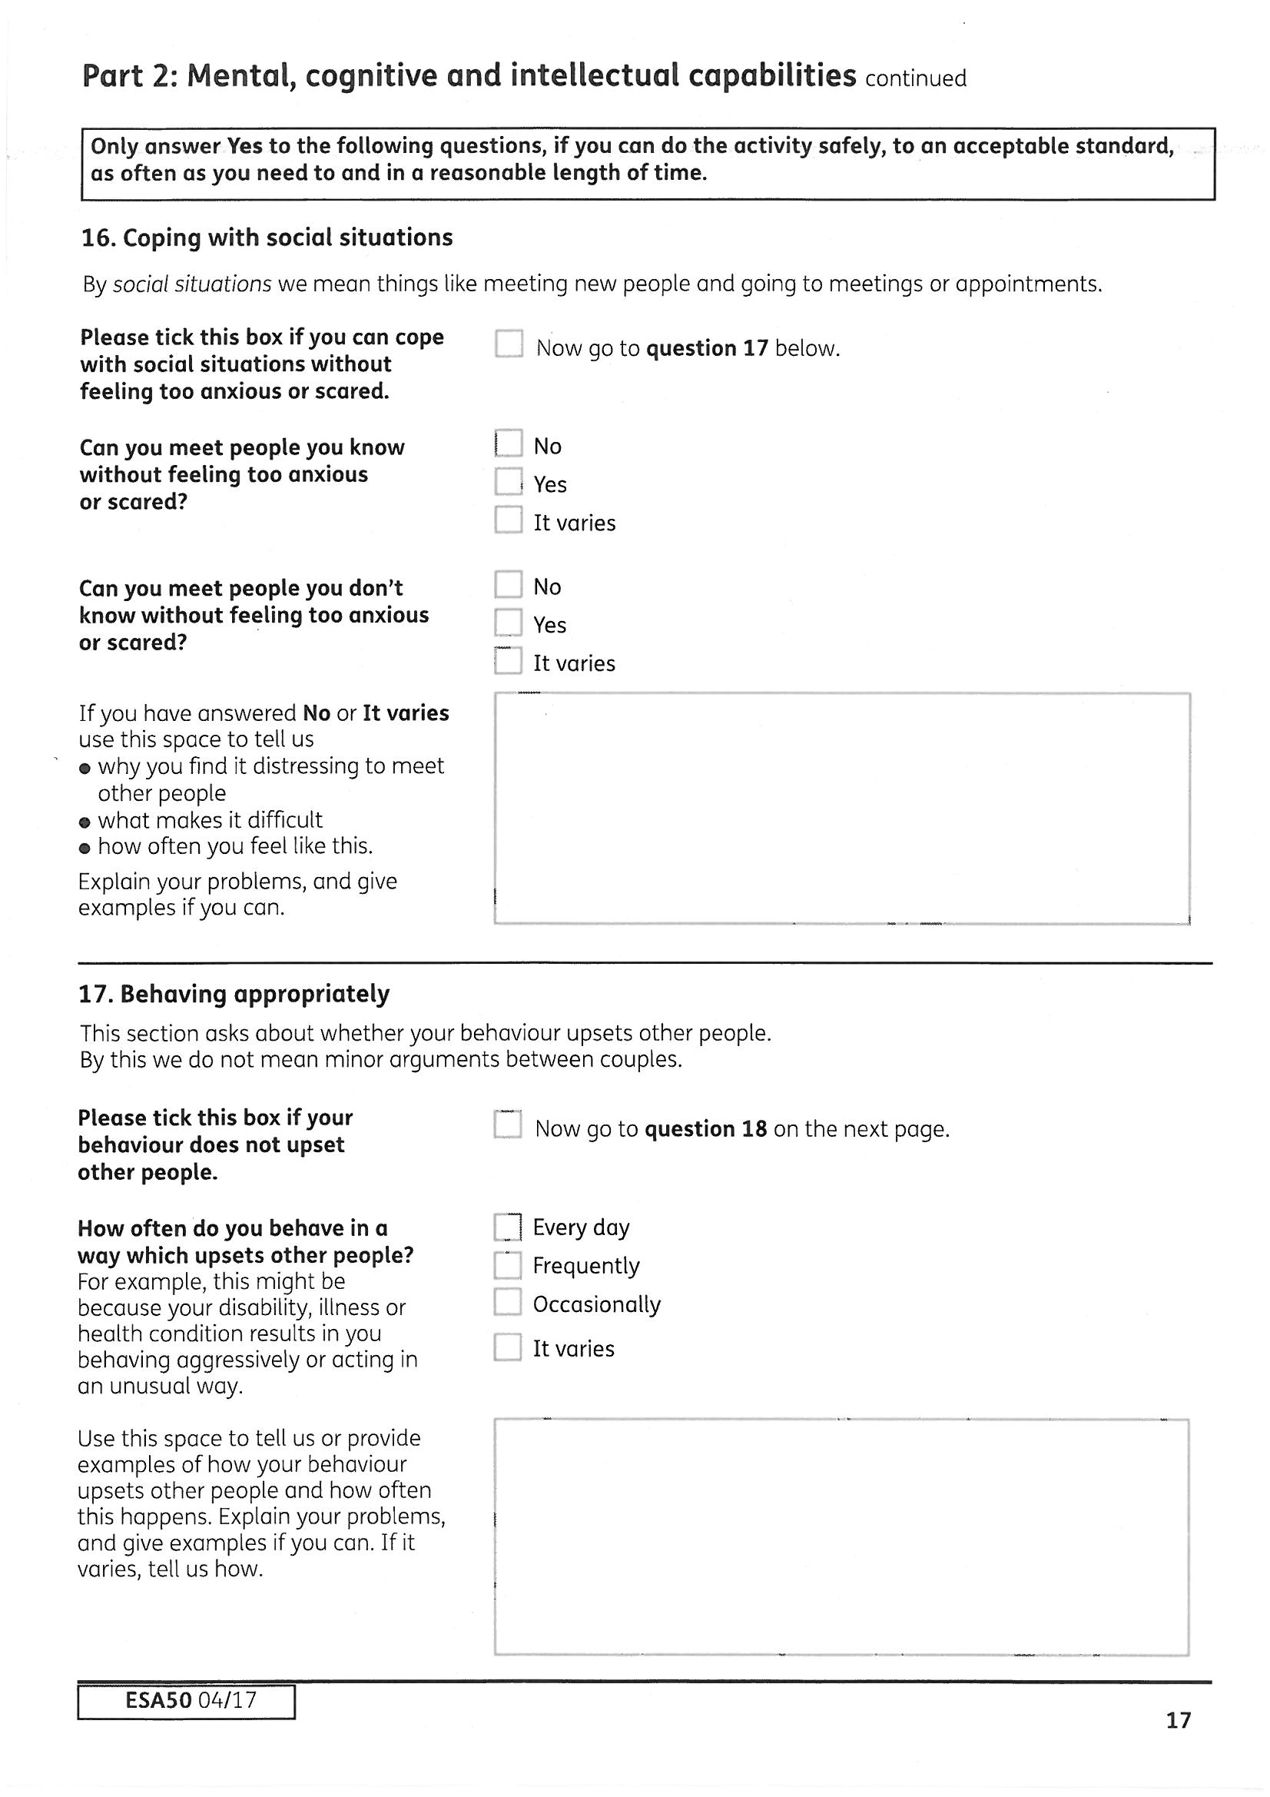
Actual TEST for 16: Coping with social engagement due to cognitive impairment or mental disorder
a. Engagement in social contact is always precluded due to difficulty relating to others/ significant distress 15*
b. As above, social contact with someone unfamiliar, always precluded 9
c. As above, social contact with someone unfamiliar, majority of the time 6
The HCP guidance says this section is for people with psychotic illnesses, brain injury causing lack of insight and autistic spectrum disorders. Do not treat this list as exhaustive. Disinhibited behaviour can occur in conditions such as bi-polar disorder or schizophrenia. If it is usually controlled by medication, how often does forgotten or overlooked medication cause an episode?
No definition is given for how often ‘frequently’ is compared to ‘occasionally’ and as yet there is no caselaw to provide any answer to this – use your judgement. Caselaw has decided that daily means more than the majority of the time but not literally every day and should be considered in relation to a workplace environment.
Describe instances of physical or verbal aggression, any behaviour viewed by others as strange, and how your behaviour can affect other people. Caselaw has confirmed that serious verbal aggression can create an unacceptable work environment for others. Behaviour that may be acceptable at home or in a Daycentre may not be acceptable in a workplace. Answer in relation to a virtual work environment such as a call centre.
Actual TEST for 17: Appropriateness of behaviour with other people due to cognitive impairment or mental disorder
Has uncontrollable episodes of aggressive or disinhibited behaviour that would be unreasonable in any workplace:
a. Daily 15*
b. Frequently 15
c. Occasionally 9
The HCP guidance says this may apply to people with significant anxiety, autism, personality disorder, psychosis or learning disabilities, with higher levels of anxiety than ‘fleeting moments of anxiety such as any person might experience from time to time’. The guidance wrongly suggests that being able to attend the medical alone and not showing signs of anxiety at the medical means this descriptor should not be met—this is a snapshot view of what could be a good day and distress is not always visible - remember you have a right to be accompanied and you should not make yourself ill by trying to attend medicals alone—cancel and rearrange if you need someone to go with you. If you have struggled to get there alone the assessor needs to know about the problems you had and how it affected you. Do not fail to attend or your benefit will stop—make sure to contact medical services to cancel.
If you are a support worker, describe how your client reacted when they first met you, whether they have not been able to attend or cope at any events you have arranged, how socially isolated they are, how anxiety affects them etc.
Some people e.g. those with autistic spectrum conditions will find more difficulty with relating to others rather than with anxiety, so explain the problems fully.
Caselaw has confirmed that for the 15 point support group descriptor—engaging with both familiar and unfamiliar people that ‘always’ means unable to engage for the majority of the time. This is due to the law on when support group descriptors should apply and provides sufficient protection against being wrongly placed in WRAC because on one occasion you coped. To reflect this the guidance has been updated and now says “always” does not mean “at all times”.
Eating and drinking are support group descriptors and NOT part of the limited capability for work test and apply to either physical or mental health or both.
Actual TEST for Conveying food or drink to the mouth
a. Cannot convey food or drink to mouth without physical assistance
b. Cannot convey food or drink to mouth without repeatedly stopping or experiencing breathlessness or severe discomfort
c. Cannot convey food or drink to mouth without receiving regular prompting by someone in your presence
d. Owing to a severe disorder of mood or behaviour fails to convey food or drink to mouth without receiving: i. physical assistance; or ii. regular prompting by someone in your presence
Actual TEST for Chewing or swallowing food or drink
a. Cannot chew or swallow food or drink
b. Cannot chew or swallow food or drink without repeatedly stopping or experiencing breathlessness or severe discomfort
c. Cannot chew or swallow food or drink without repeatedly receiving regular prompting by someone in your presence
d. Owing to a severe disorder of mood or behaviour fails to: i. chew or swallow food; or ii. chew or swallow food or drink without regular prompting by someone in your presence
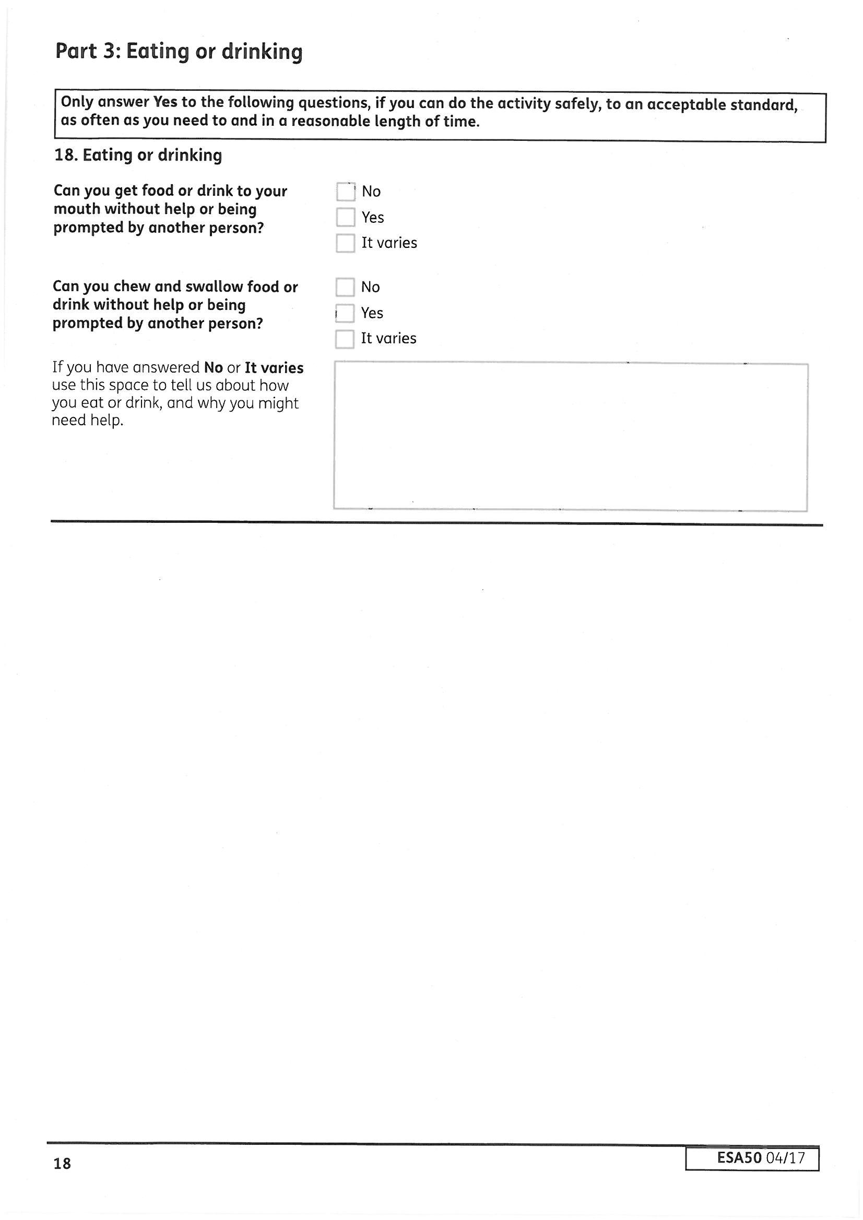
If you are awarded either of these support group activities but do not score enough points on the limited capability for work test—you will be treated as having limited capability for work as well as limited capability for work related activity and entitled to ESA.
The descriptors apply to a range of physical problems including the use of limbs to get food to your mouth, throat and stomach problems, severe breathing problems etc.
For mental health problems it could include both eating disorders and conditions such as psychosis, anxiety about swallowing, severe apathy—any problems that mean you need prompting to eat or drink for the majority of the time.
It is not that you cannot eat or drink at all, but whether you have problems for the majority of the time.
Caselaw has confirmed that if you can drink but not eat, then it should still apply. The caselaw also states that the phrase ‘cannot chew or swallow food means ‘cannot either chew or swallow food’, or to put it another way, ‘cannot chew and swallow food’ (but not ‘can neither chew nor swallow food’).
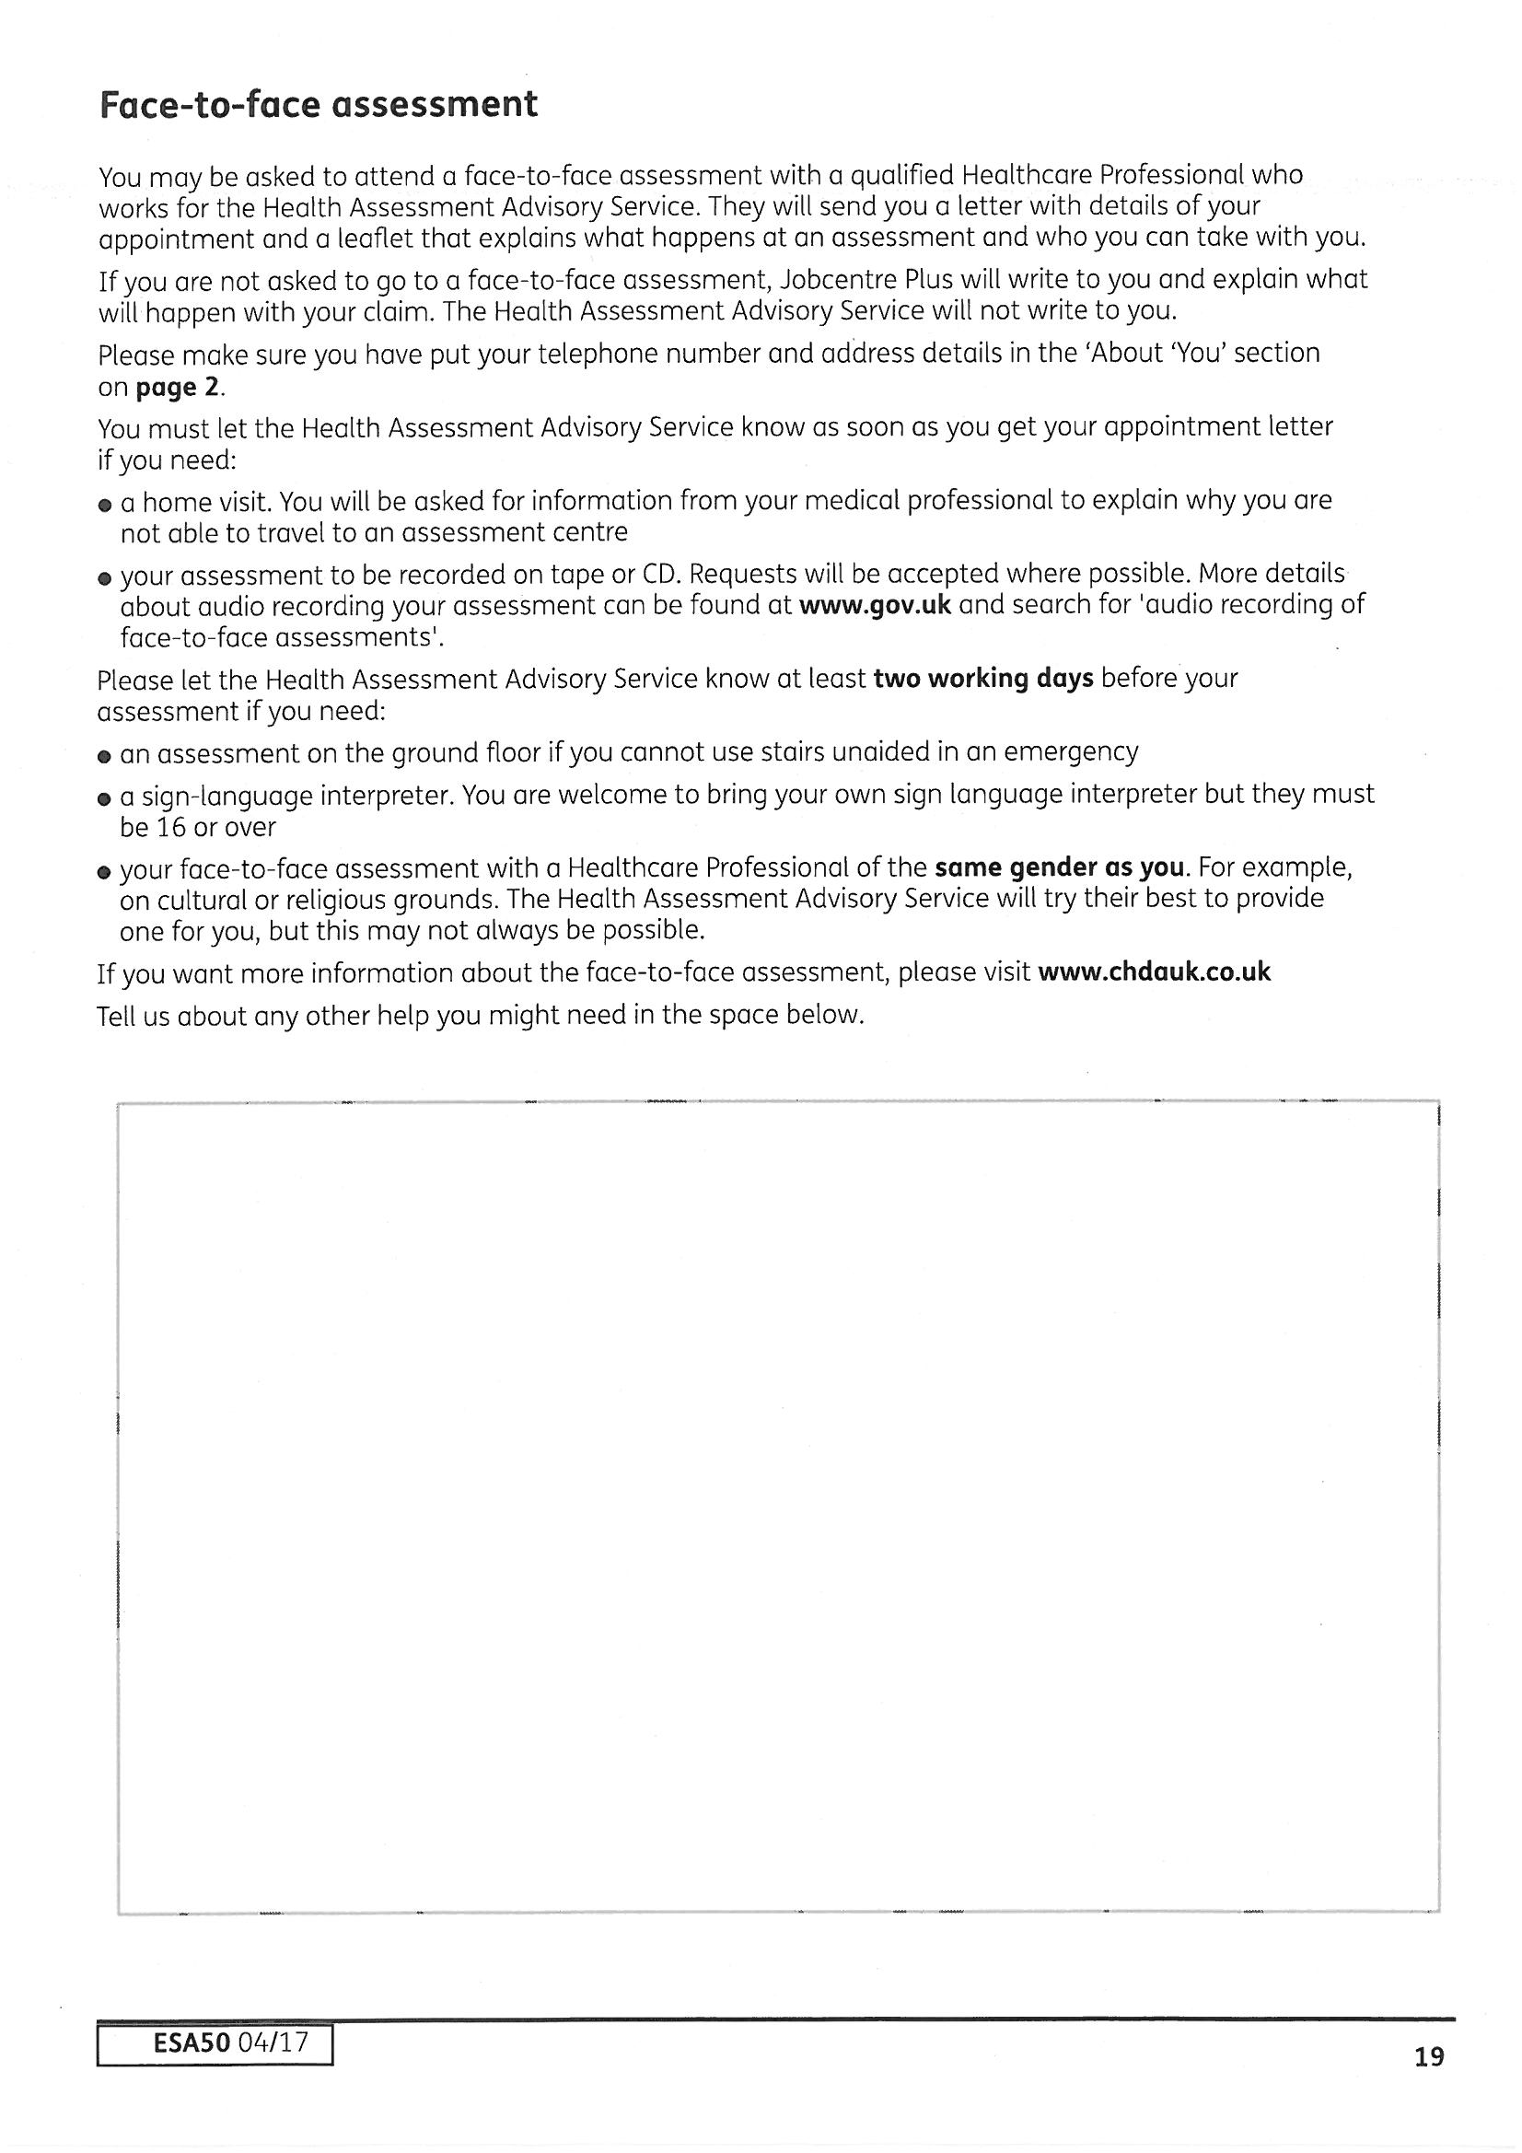
If you have problems going out or coping with social situations, and prefer not to go out alone, you can take someone with you; if no one is available to go with you, you should inform the Health Assessment Advisory Service (Maximus) that you have to cancel the appointment.
This is better than making yourself ill by going alone especially as the decision maker may not be aware of the difficulties you had getting there or how it affected your health.

Your benefit will stop if you don’t turn up for the medical. You must always notify them if you need to cancel and re-arrange another appointment.
It is ok to say: “X does not/cannot deal with correspondence due to mental health problems/learning difficulties/ etc (give details). Please contact Z instead.” Explain if someone else should be contacted to arrange a medical for you. Put, “Please ring X instead” then explain why, e.g. “because I don’t answer the phone to someone I don’t know,” or, “due to memory loss I would not remember the appointment date ” etc. Make sure you include their contact details.

Non attendance at medicals 'without good cause' leads to 'fit for work decision' and ESA stops. This decision can be challenged - mandatory reconsideration followed by appeal - write to say you are asking for the decision to be looked at again because there was 'good cause' for non-attendance. ESA is NOT paid pending appeal in these cases. Claimants will USUALLY need to claim JSA/UC and be actively seeking and available for work but there may be other options: get advice.
If there are problems attending a face-to-face assessment at a medical centre (in Swansea this is at Grove House, Alexandra Road, say why. “I need my support worker/someone else with me due to mental health problems /anxiety/learning disability/problems using transport alone/ I cannot attend because I am housebound and need a home visit”. Give details, eg - agoraphobia/mobility problems.
If a home visit is needed try to attach medical evidence to confirm this.
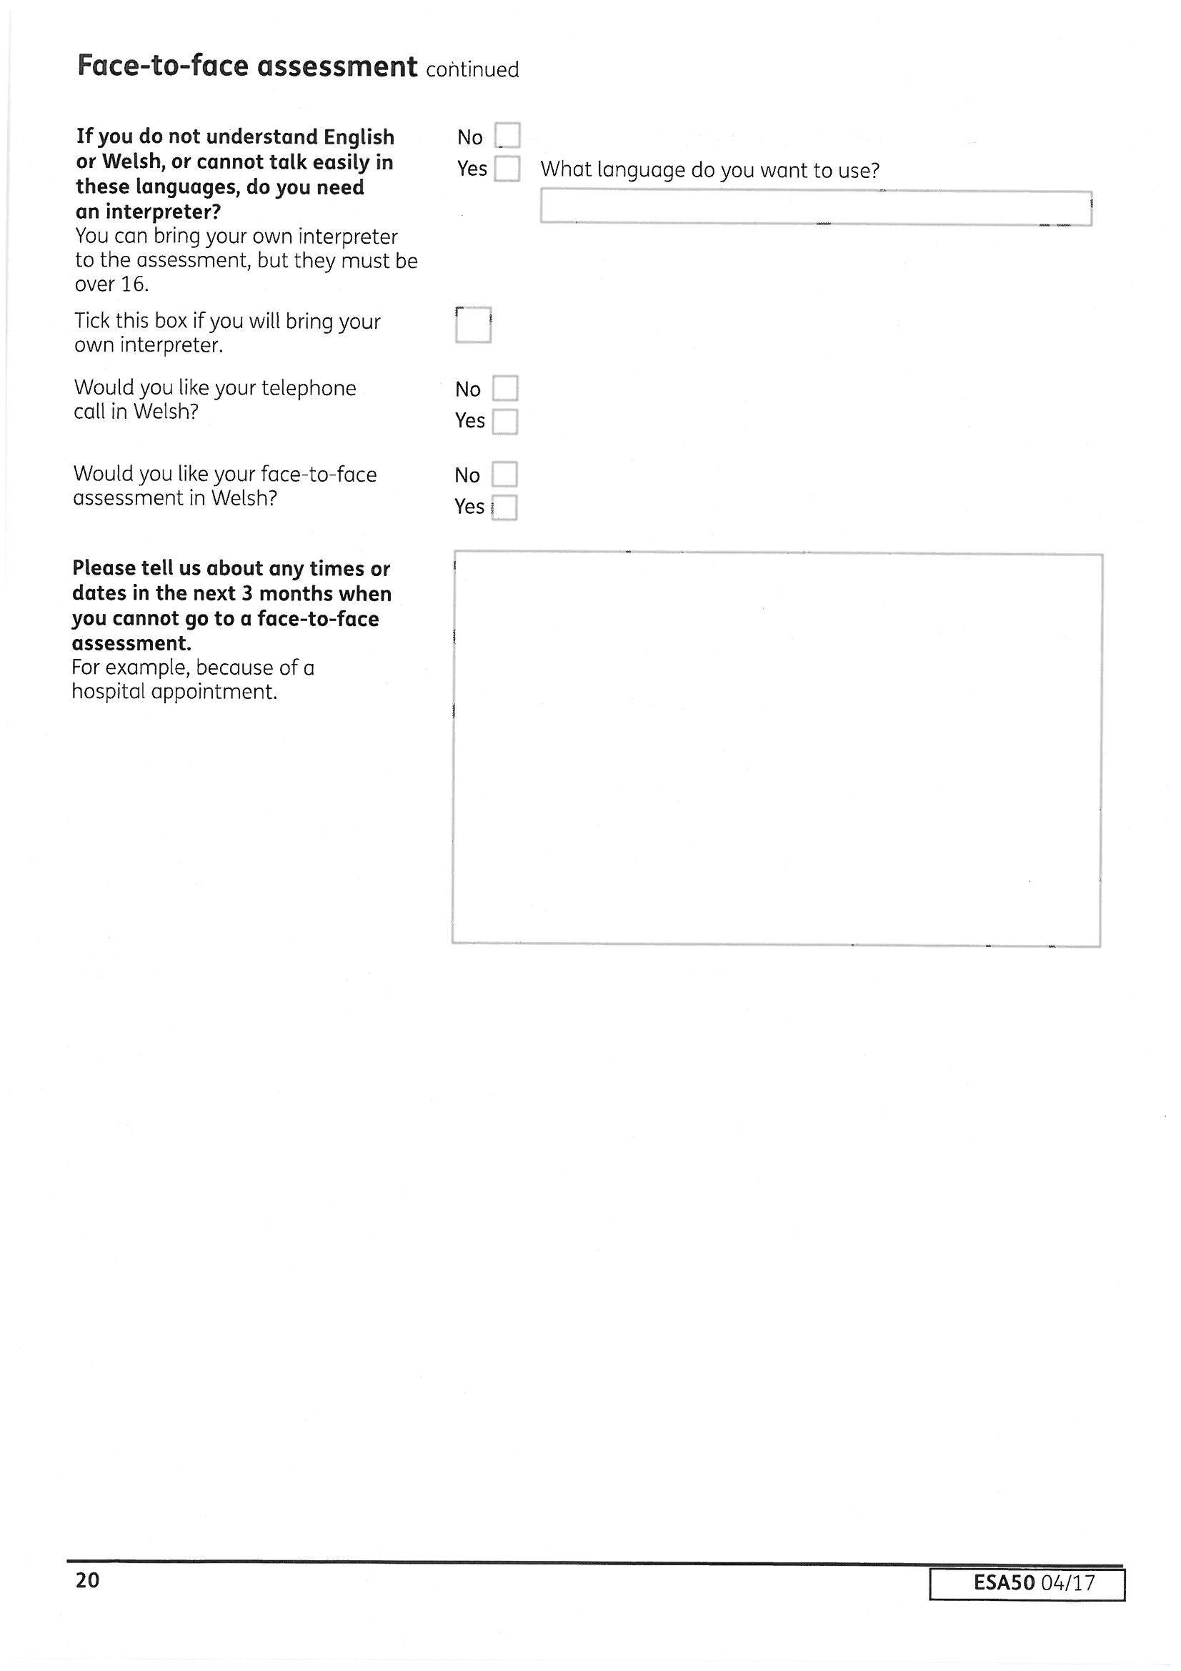
Also include unavailable dates for anyone attending WITH the claimant.
Claimants with problems going out have a right to wait until someone can come with them rather than face the distress of trying to struggle there by themselves.

The descriptors marked with a * plus the eating and drinking descriptors are the descriptors for having limited capability for work related activity. You only need to be awarded one of these descriptors to be found to have BOTH limited capability for work (except eating and drinking they are all 15 point descriptors) and limited capability for work related activity and placed in the support group of ESA.
The support group is important, not just because the support component is paid at a higher level, (for new claims from 03/04/17 no extra component is included if you are found to only have limited capability for work) and entitles you to an additional premium in income-related ESA. Also being placed in the support group means you are not limited to only being paid contribution based ESA for a year.
One of the most important reason for being placed in the support is that you do not have to participate in work focused interviews or work related activity and cannot be sanctioned for being unable to participate.
Think about if you are currently able to attempt work related activity—going to interviews with a work coach at the jobcentre, attending CV writing courses, basic skills courses, telephone support, attend expert patients programme etc, what is available locally will vary. If you believe that this type of activity would be damaging to your mental health, cause a relapse into substance misuse, be physically damaging to your health—explain this here in detail and include examples of what has happened before and the affect it had on your health if possible. If you might be able to cope if someone familiar could go with you, but you cannot count on having anyone available eg; your partner works or your support worker can only help you once a week and this is time limited, explain this here. Think about all types of work related activity, you may be coping with an occasional phone call from the Jobcentre adviser, but if you were asked to attend a course with other people you do not know, would you still be able to cope?
Nowhere on the form are you actually asked if either being found fit for work (including having to claim as a jobseeker) or fit for work-related activity would create a risk to either your physical or mental health. This is very IMPORTANT because even if you do not score enough points to be found to have limited capability for work or do not meet a support group descriptor and found not to have limited capability for work related activity, you can still pass the test due to ‘exceptional circumstances’, or what is known as regulation 29 and 35. These are the legal regulations stating you cannot be found fit for work/work-related activity if this would cause a substantial risk to your health.
Although these exceptional circumstances apply to both physical and mental health, in practice we find that we usually argue this on mental health grounds. Think about not being able to go somewhere unfamiliar alone and not being able to cope with engaging with unfamiliar people because it makes your anxiety levels rise to a level you cannot cope with—yet still being found fit for work. So explain this in or any other risk to your health in detail here.
If you are found fit for work or placed in the Work Related Activity Group when you believe you should be in the support group—you are entitled to request a mandatory reconsideration from the DWP and if not successful you can request an independent appeal. You have a month time limit from the decision date to request a mandatory reconsideration and a month after this decision to lodge an appeal. However if you miss these deadlines and it has not been 13 months since the decision, you can request a late mandatory reconsideration/appeal if you explain your reasons for being late. Late requests are usually accepted if you can provide both good reasons for lateness and good grounds for disagreeing with the decision, but the later it is the more compelling the reasons for being late need to be. If you need to challenge an ESA decision - GET INDEPENDENT ADVICE.
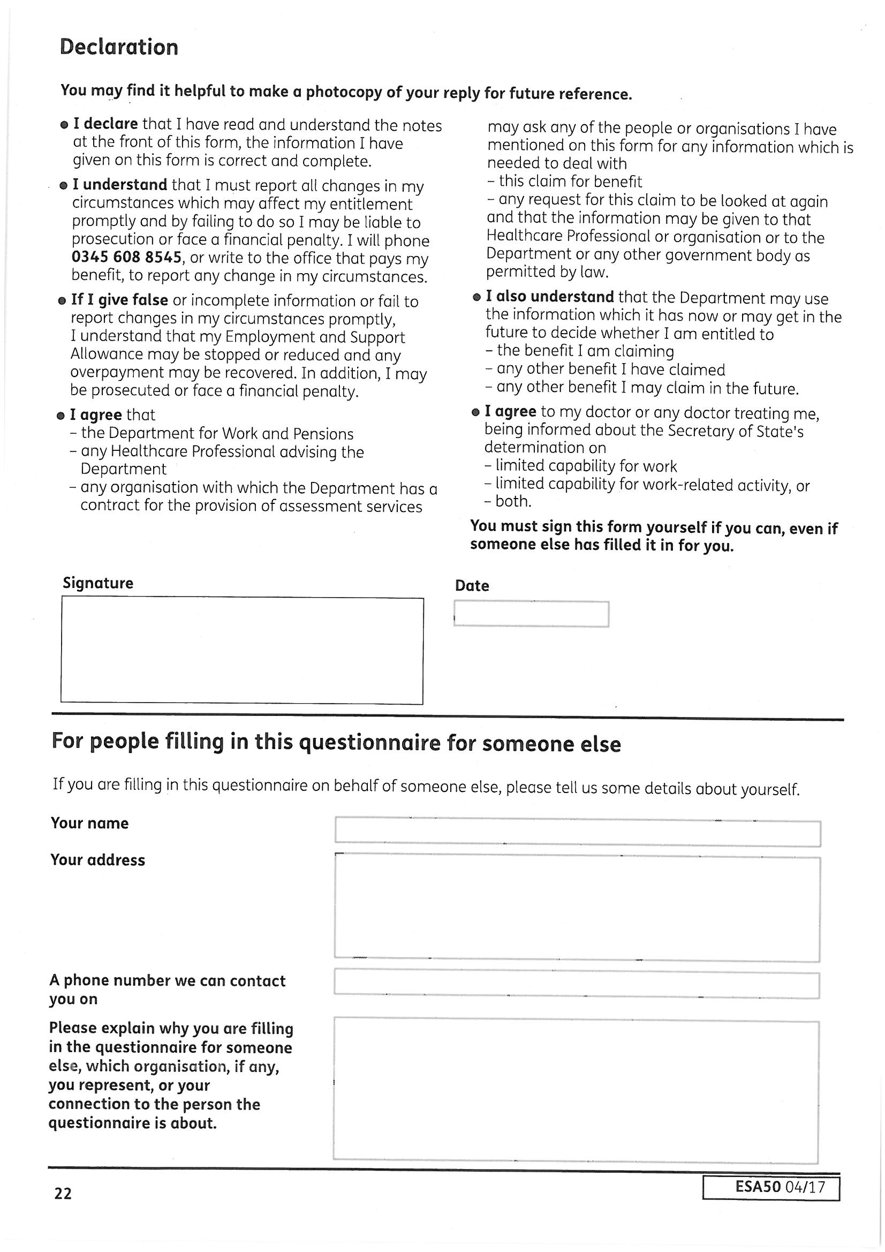
It is important to explain if you are not capable of completing the form yourself and why you needed help. A standard entry on the medical report (called the ESA85) following the medical is ‘completed esa50 without difficulty’. This can give the wrong impression of your health problems.
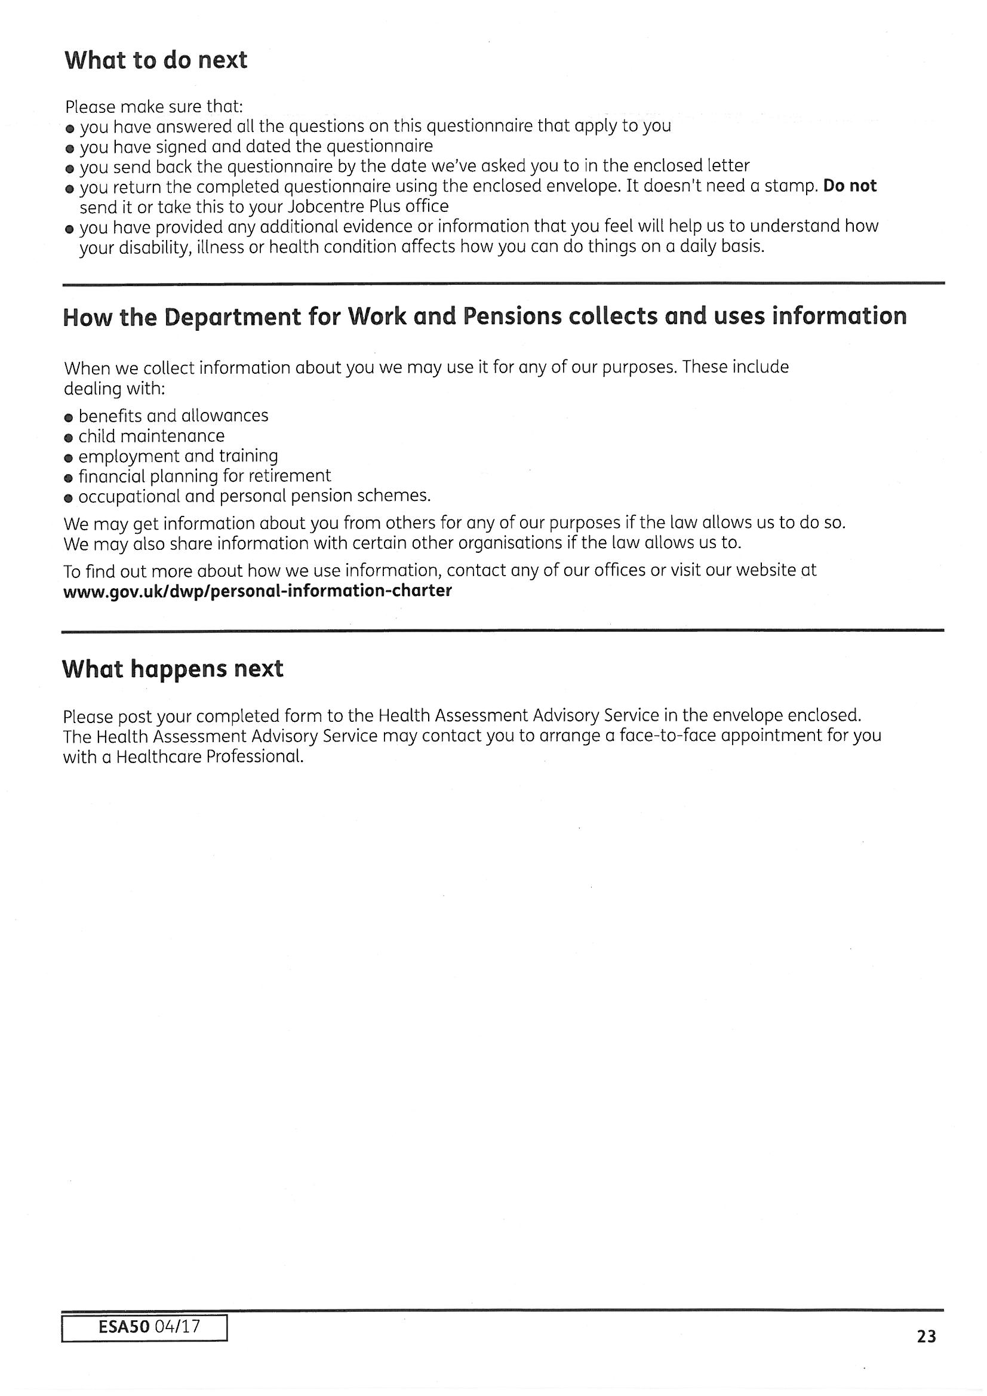

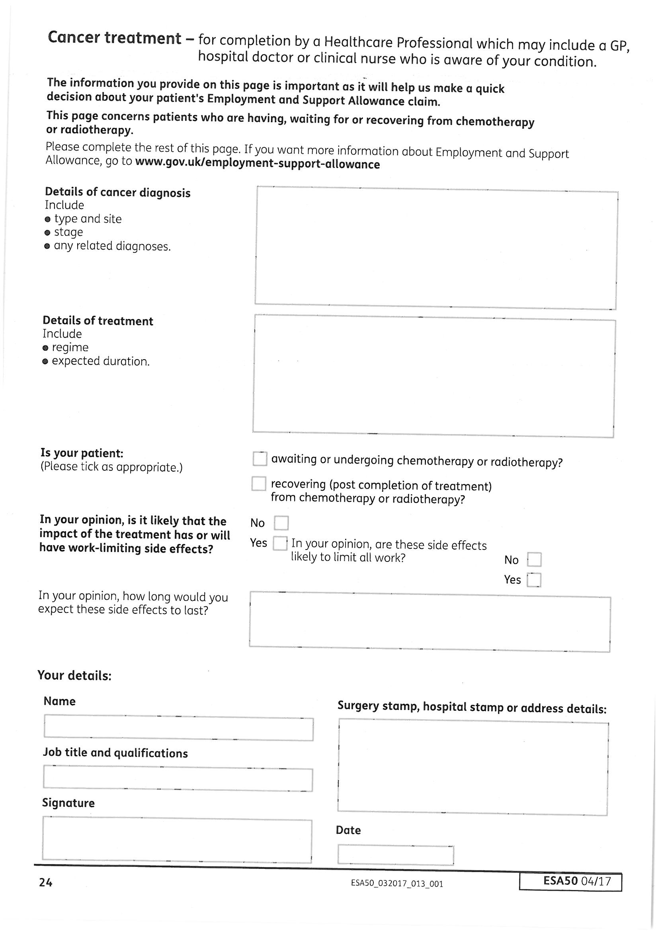
Remember if you have ticked yes to having cancer treatment on page 4 that you need to ask your doctor or nurse to complete this.

