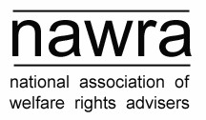

Friday 1st March 2013

City Hall (formerly known as Council House), College Green,
Bristol BS1 5TR

Hosted by Bristol City Council Welfare Rights and Money Advice Service

Agenda

9.30 | Registration and coffee/tea
10.00 | Welcome – From George Ferguson, the Mayor of Bristol
10.15 | David Gordon - Centre for the Study of Poverty and Social Justice, Bristol University  Causes, effects and impacts around the changes to housing benefit
10.55 | Alison Garnham - chief executive, Child Poverty Action Group  Social security policy – where do we go from here?
11.35 | Coffee/tea
11.50 | Workshops (for details see below)
12.50 | Lunch – this will not be provided. However, there are plenty options within easy reach of the venue.
2.00 | NAWRA Annual General Meeting - annual report, motions to the AGM and financial report
2.15 | Workshops (for details see below)
3.15 | Coffee/tea
3.30 | Feedback from workshops and information exchange
4.00 | Close

If you have any queries about the meeting please contact
Kelly Smith, NAWRA Secretary nawra@cpag.org.uk

GUEST SPEAKERS

David Gordon is currently the director of the Townsend Centre for International Poverty Research. His research interests include social and distributional justice, social harm, child poverty, child poverty & human rights, crime and poverty, the causal effects of poverty on ill health and rural poverty.

Alison Garnham became Chief Executive of the Child Poverty Action Group (CPAG) in September 2010 and before that was the CEO of Daycare Trust - since June 2006. Prior to this, for nine years, she was the Director of Policy, Research and Information at One Parent Families (now Gingerbread). She worked for many years as a welfare rights adviser and for a number of women’s organisations and local voluntary sector organisations before, in 1989, joining CPAG (for the first time) where she co-authored a number of publications about the Child Support Act. She has subsequently written about lone parenthood and child poverty, including an edition of Poverty: the Facts, published by CPAG. Before joining One Parent Families she was Senior Lecturer in Social Policy at the University of North London (now London Metropolitan University) where she has also been an Honorary Research Fellow. She was a Trustee and Honorary Officer of the End Child Poverty Campaign, was for nine years a member of the Social Security Advisory Committee and is a parent-governor at her son’s primary school.

Alison will be talking about 'welfare' reform since 2010: the impact of welfare reform; concerns and future prospects; re-establishing ‘social security’; prospects for ending child poverty.

WORKSHOP OPTIONS

Workshops are all one hour. Please choose one workshop to attend in the morning session (11.50-12.50) and one to attend in the afternoon session (2.15-3.15). Please note, not all workshops will run twice; see below for details.

Returning to working after/during mental illness - Paul Broadhead, Bristol Vocational Service
(afternoon session only)

Paul has worked as an Occupational Therapist with an employment specialism for the last five and a half years for Bristol Vocational Service, part of Avon & Wiltshire Mental Health Partnership NHS Trust. BVS is a Bristol wide team that receives referrals from secondary mental health teams and works with anyone with a motivational desire to work. Paul sees his role as helping people to think about the best job and environment in which they can work. Paul will talk about his work in general and will provide some helpful case study examples.

- Everyone’s a winner: working with law students to deliver specialist advice and advocacy - Andy King, Avon & Bristol Law Centre
(morning session only)

Andy has worked in Bristol as a welfare benefits adviser for 25 years and has been involved in project development for a number of new advice services and initiatives. Currently he is employed by Avon and Bristol Law Centre.
Andy will be talking about an innovative pilot project for recruiting, training and supervising law students in providing specialist legal advice and advocacy for Work Capability Assessments appellants. The imminent end of LSC welfare benefits contracts will reduce advice and advocacy provision at a time when demand is higher than ever before. Andy is one of many practitioners who are looking at ways of making their experience and skills spread further.

Conditionality and sanctions - Martin Williams, Child Poverty Action Group

(morning and afternoon sessions)

Martin is a welfare rights worker at CPAG. He is widely experienced in representing claimants at both levels within the tribunal system having worked at LASA, in a local authority and for an independent advice centre. Martin is an author of CPAG’s ‘Welfare Benefits and Tax Credits Handbook’ and ‘Housing Benefit and Council Tax Benefit: the Legislation’.

Martin will be looking at tips and tricks in assisting claimants to avoid the imposition of conditionality and to challenge sanctions arising from failure to meet the various work-related requirements.

Stimulant Awareness - Pat Rose, Nilaari
(morning session only)

Pat has 13 years experience as a Senior Practitioner with Nilaari, a community based drug treatment provider that administers accessible, high quality and culturally appropriate counselling, advocacy and support primarily (but not exclusively) to Black Asian & Minority Ethnic (BAME) adults and young people in Bristol who are involved in or at risk of misusing drugs and/or alcohol. She has a background in social work, criminal justice and mental health.

This workshop will be a mixture of information giving and interactive exercises with a chance to ask questions. It will cover: understanding stimulant use, facts about stimulants including health effects, physiology and neurology, and specific treatment interventions.

Winning Ways: tips for effective representation- Martha Street, District Judge
(afternoon session only)

Martha has been a District Tribunal Judge for 18 years. Her previous career included five years in a Welfare Rights Advice Centre, followed by private practice as a solicitor combined with writing and training portfolio, including welfare rights.

This workshop will look at representation skills and how to be more effective.

Personal Independence Payment review and implementation- Kathryn Wright and Julie Burton, Durham Council
(morning and afternoon sessions)

Julie and Kathryn are both welfare rights advisers with Durham County Council. Julie jointly developed and tutored on Teeside University's Social Security: Policy and Practice qualification. Within Durham County Council she is employed as a Principal Welfare Rights Officer and manages a range of core and commissioned activities, including casework services, tribunal work and the dedicated Welfare Rights provision including Sensory Support, Learning Disability, Mental Health and the safeguarding and specialist services. Kathryn moved to Durham County Council in 2004 to work on an innovative project developing online and video conferencing welfare rights advice. Specialising in benefits for young disabled children she now delivers a project to families and those in transition. Kathryn delivers training and workshops to a wide range of organisations on Welfare Reform and other benefit topics.

This workshop will review the December amendments and the implementation of PIP. We will also look at the new claim form and correspondence that will be sent to claimants and examine pitfalls faced by some claimant groups

LOCATION AND TRANSPORT

The meeting will be held at City Hall (formerly known as Council House), College Green, Bristol

BS1 5TR.
http://www.bristol.gov.uk/page/city-hall-formerly-council-house-venue-hire

Map showing location of City Hall
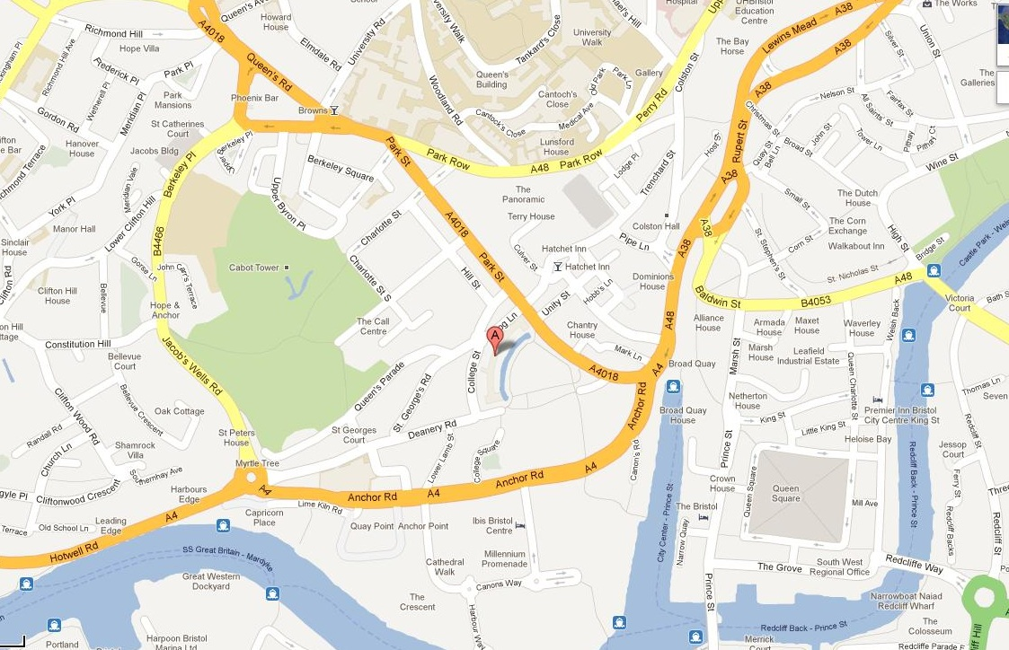

By car:
From the M4 – take junction 19 onto the M32 and follow all the way into the city centre.
From the M5 – exit at either Junction 16 and follow the A38 into the city centre. Or exit at Junction 17 and follow the A4018 into the city centre.

Trenchard Street car park
http://en.parkopedia.co.uk/parking/carpark/trenchard_street/bs1/bristol/

Park and Ride
http://www.parkandride.net/bristol/index.shtml

By train:
To Bristol Temple Meads station

By bus:
Buses to College Green by City Hall use services 8 and 9 (leave every 6-10 minutes – journey time approx 10 minutes)

ACCOMMODATION

Budget hotels close to the venue include:

Ibis – Bristol Centre
http://www.ibishotel.com/gb/hotel-5547-ibis-bristol-centre/index.shtml

- Travelodge – Bristol Central
www.travelodge.co.uk

For alternatives visit www.laterooms.com, www.tripadvisor.co.uk, www.hotelscombined.com or other online agents.

THURSDAY NIGHT SOCIAL

In standard NAWRA tradition the committee and local NAWRA members will be making themselves available to provide sparkling and witty company so if you're travelling down on Thursday 28th February come and join us from 7pm at:
Renato's, 19 King Street, Bristol BS1 4EF
You can just come for a drink, enjoy a pizza in the bar area or if you want to be a bit more classy go up to the restaurant upstairs. Plenty of other food places in the area if Italian doesn't tickle your fancy!
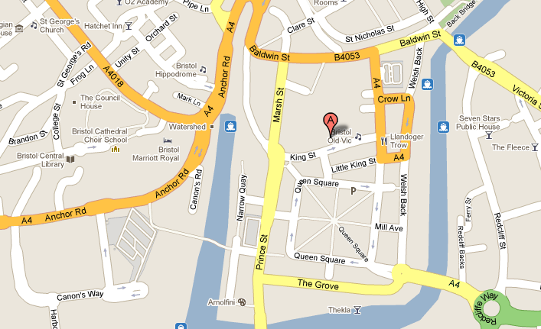
Map showing location of Renato’s

For those who want to make a weekend of it The Selector are playing at the Fleece (12 St Thomas Street, Bristol BS1 6JJ) on Friday 1st March supported by Talisman. A number of us are staying on and anyone is welcome to join us. You can book tickets online at www.thefleece.co.uk

