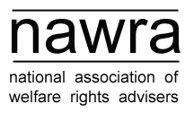

Friday 9th March 2012
@ Amnesty International UK, The Human Rights Action Centre,
17-25 New Inn Yard, London EC2A 3EA

Booking form

NAWRA meetings are free for members to attend. However, space at the venue is limited so advance booking is necessary.

Please complete your delegate details below and return to Kelly Smith, NAWRA Secretary, by email: nawra@cpag.org.uk

Name of delegate | Organisation

Kelly Smith

NAWRA Secretary

94 White Lion Street, London N1 9PF

nawra@cpag.org.uk

tel: 020 7837 7979 (ext. 246)

fax: 020 7837 6414

www.nawra.org.uk

