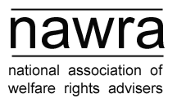
Equality and Diversity Working Group
2-3pm on 12 May 2022
Agenda
- Apologies
- Notes from the last meeting(s) – these can be found at on the NAWRA website at https://www.nawra.org.uk/about-nawra/equality-and-diversity/
- Researching and adopting good practice guides written by other organisations
- Making a commitment to equality and diversity a condition of joining NAWRA at
signup stage
- Examining barriers to entry and establishing a scheme to allow small organisations
with little funding to join NAWRA for a reduced fee or for free (free membership available now).
- Contributing to work on equality and diversity in the wider rights and advice sector
- The direction of the working group going forward
- Next meeting
- AOB

If you need any items added on the agenda, please contact Atif at atif.kaudri@nawra.org.uk

